1.Log in to the system as root.

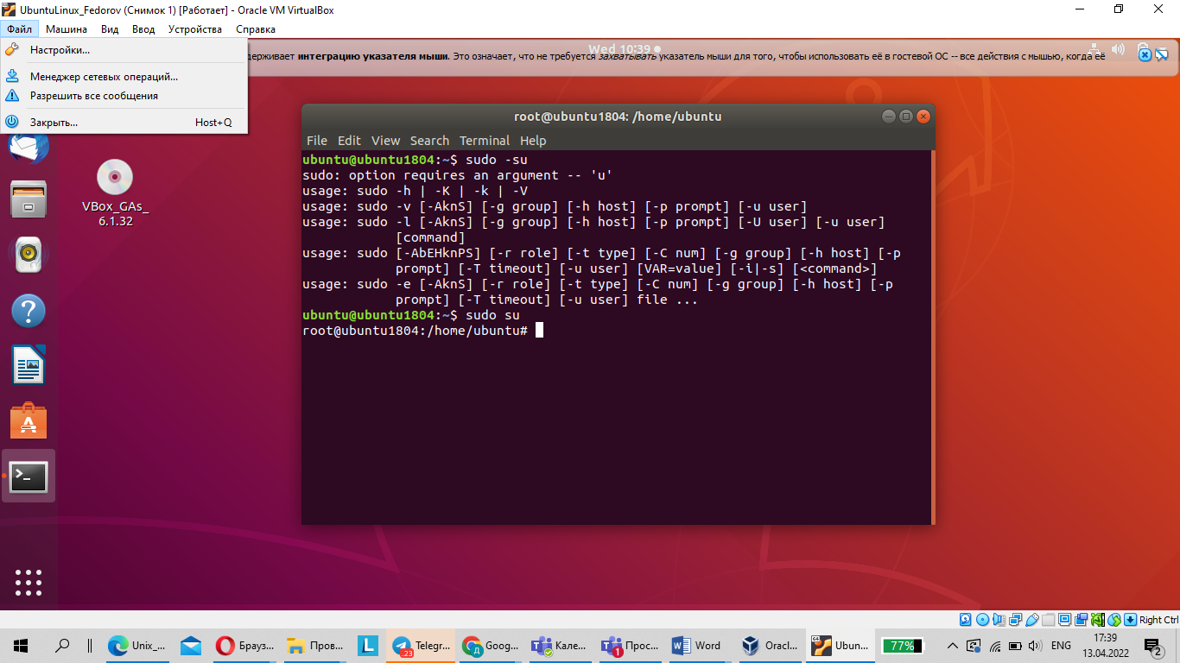

2. Use the passwd command to change the password. Examine the basic parameters of the command. What system file does it change *?

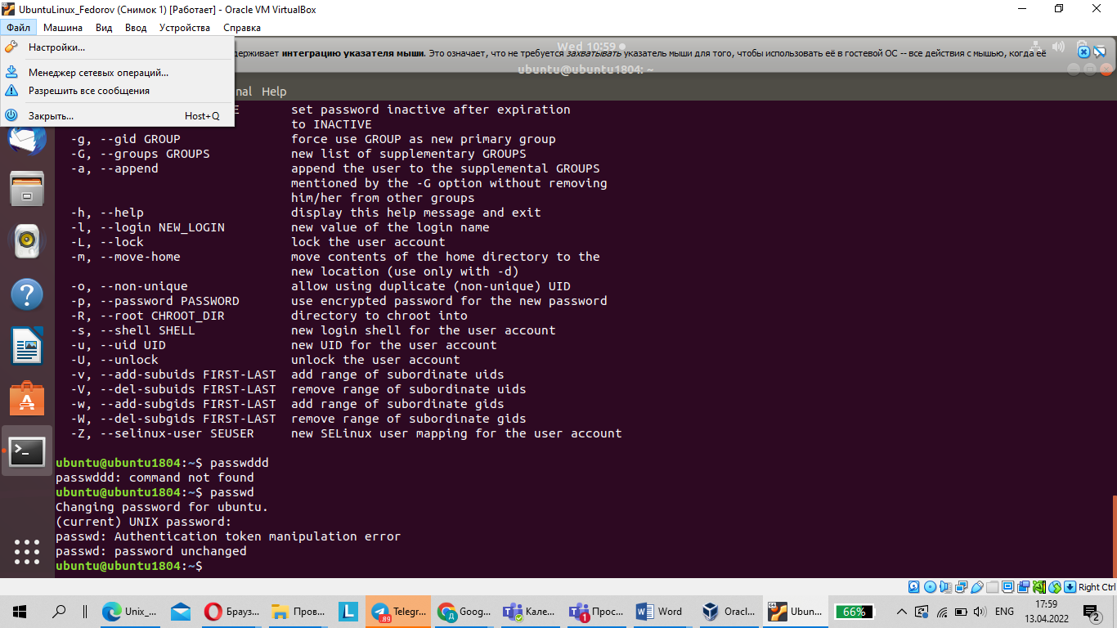

1. Determine the users registered in the system, as well as what commands they execute. What additional information can be gleaned from the command execution?

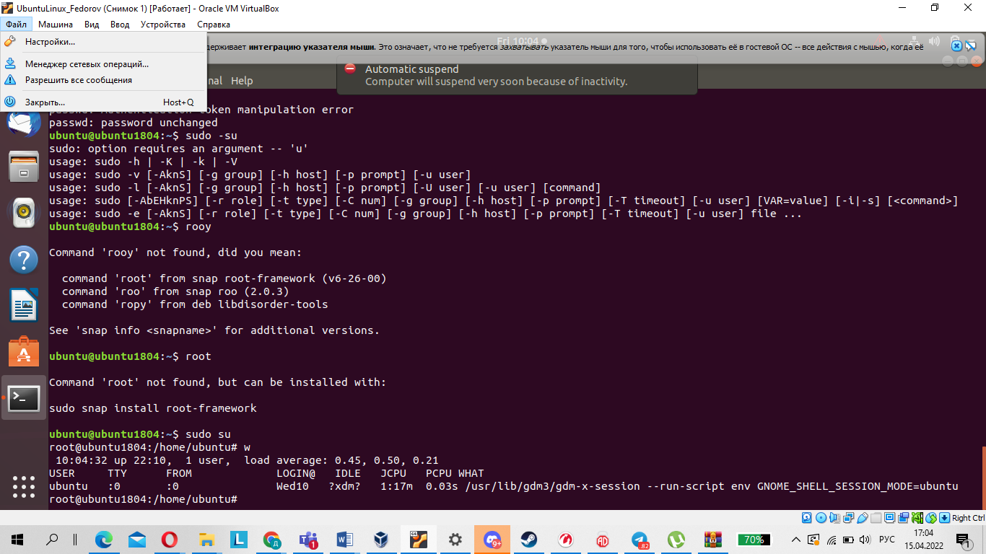

1. Change personal information about yourself.

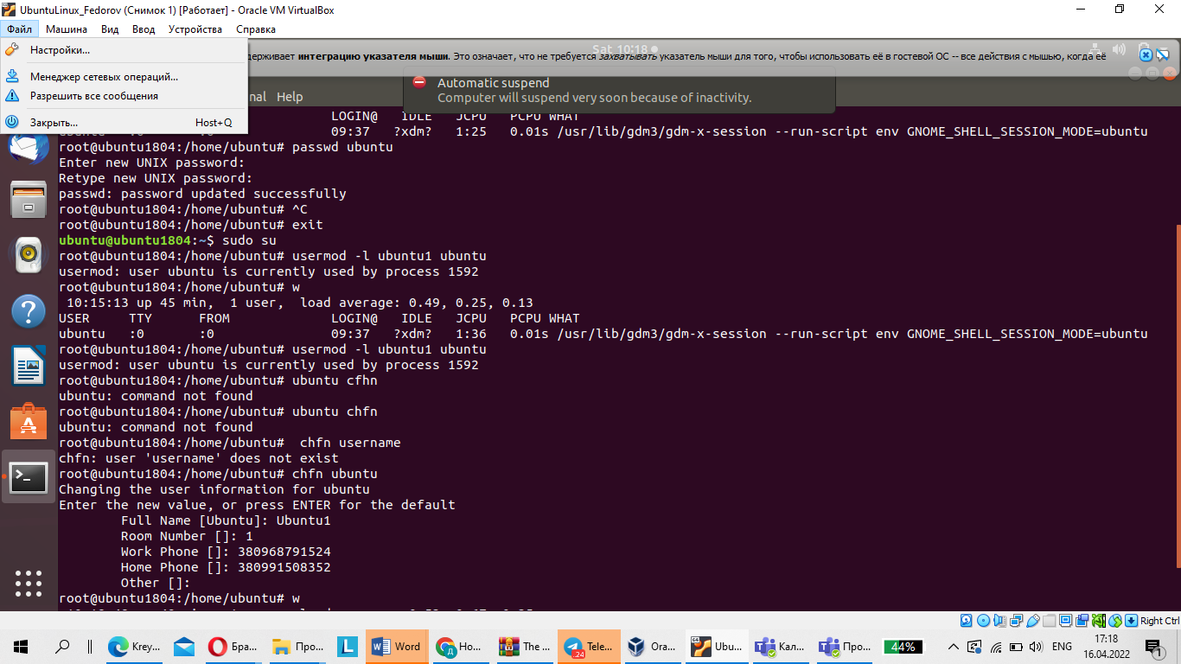

1. Change personal information about yourself.

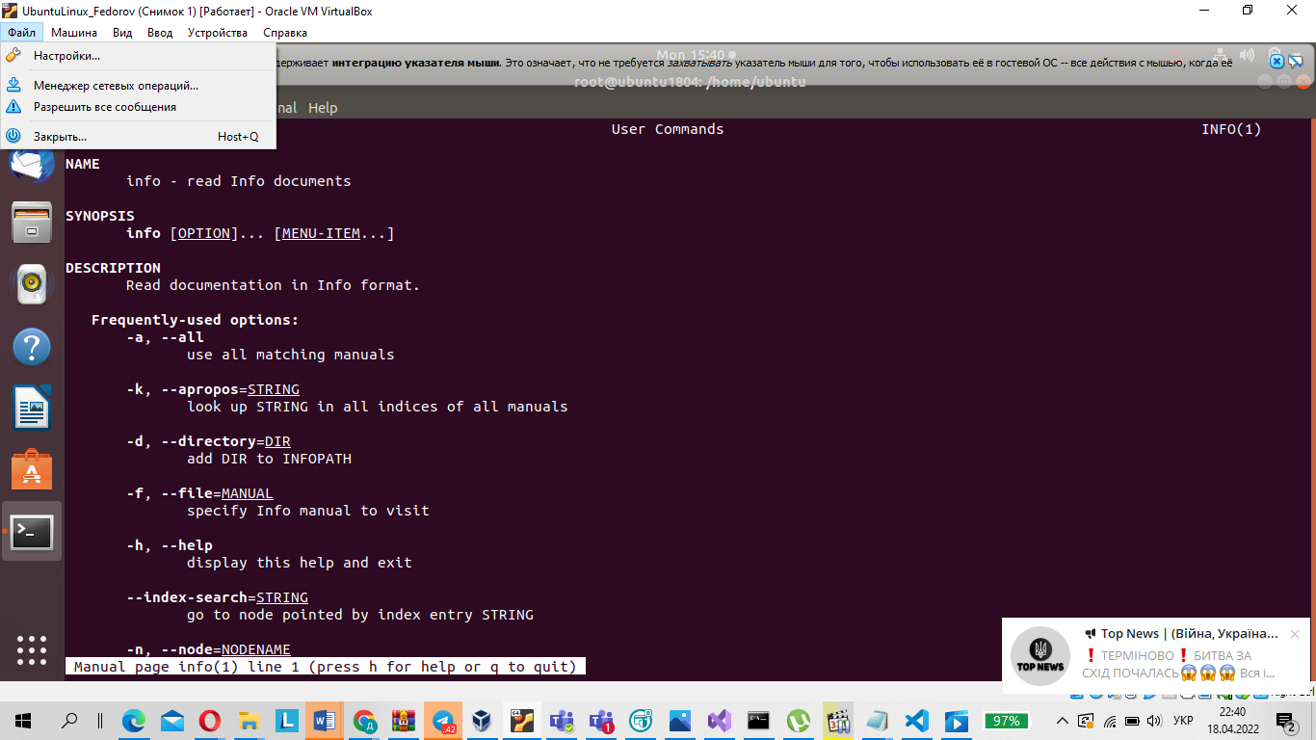

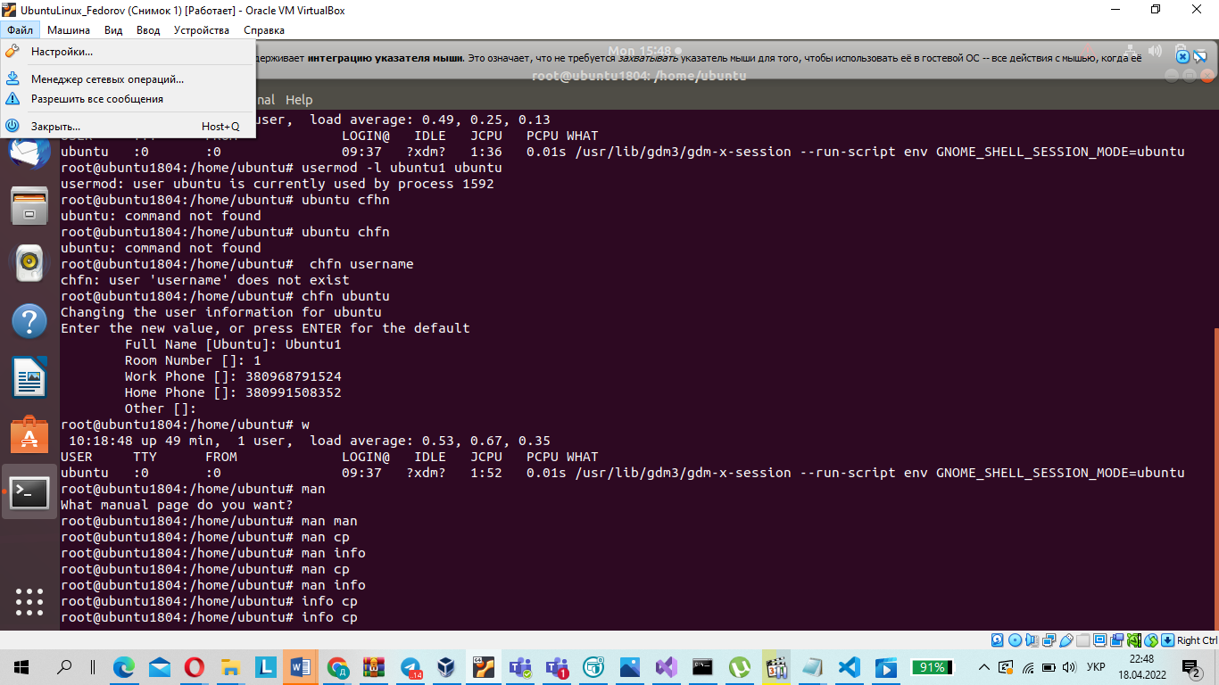

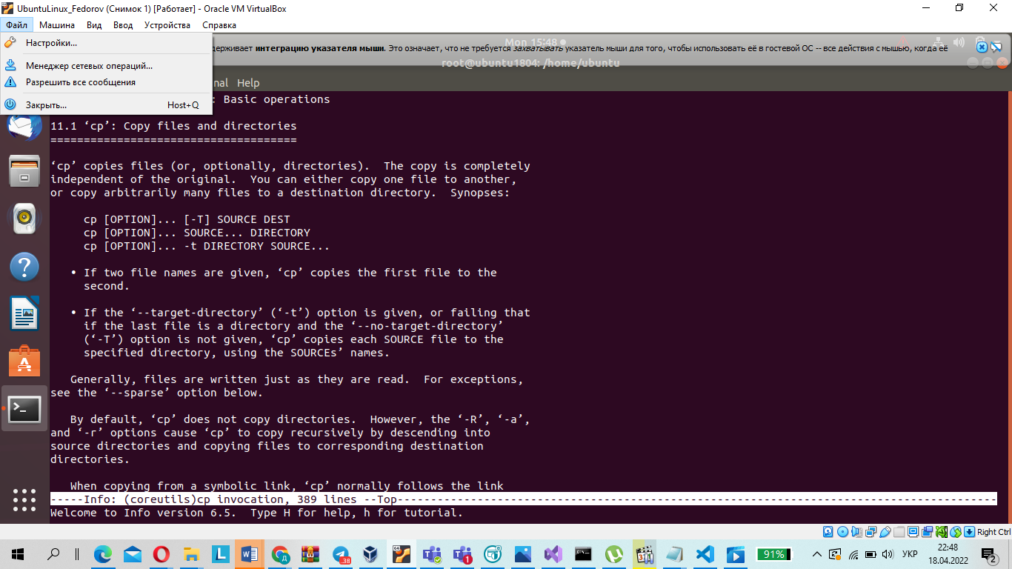

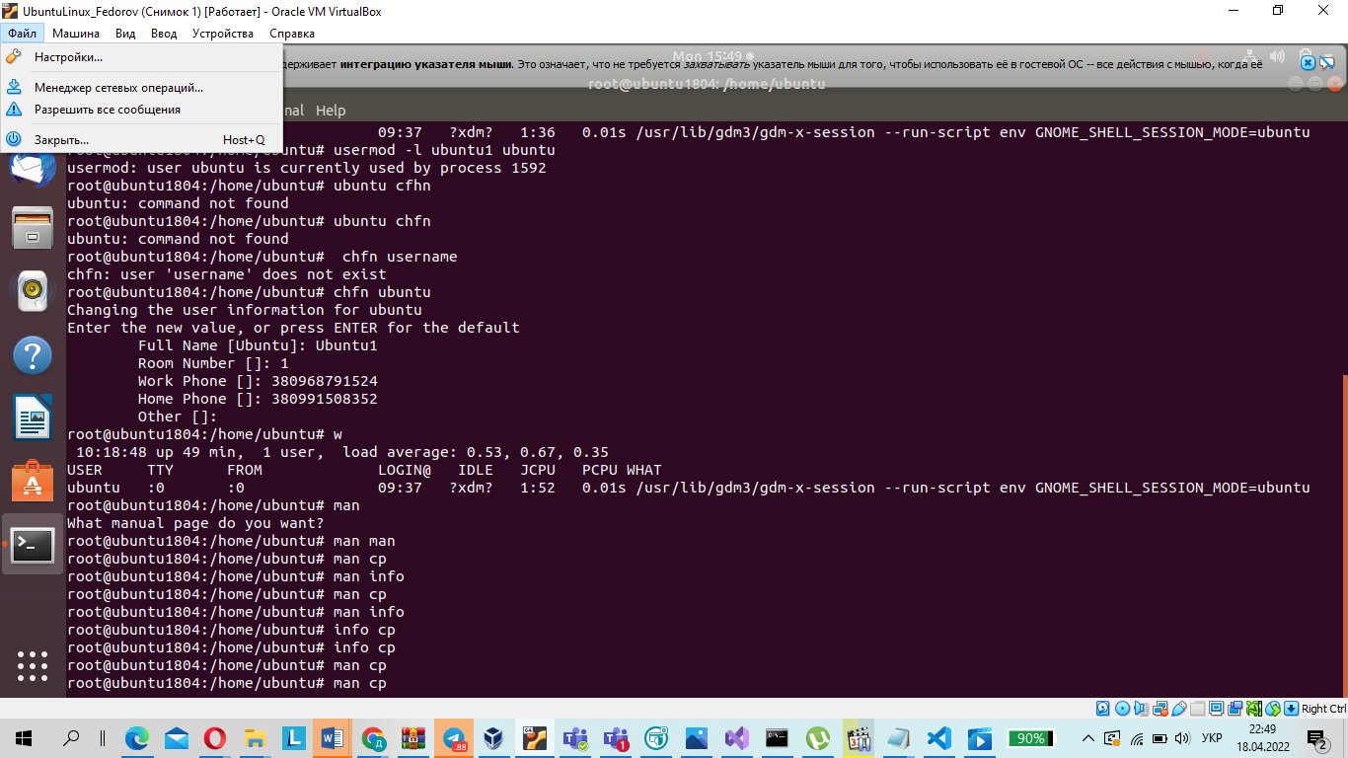

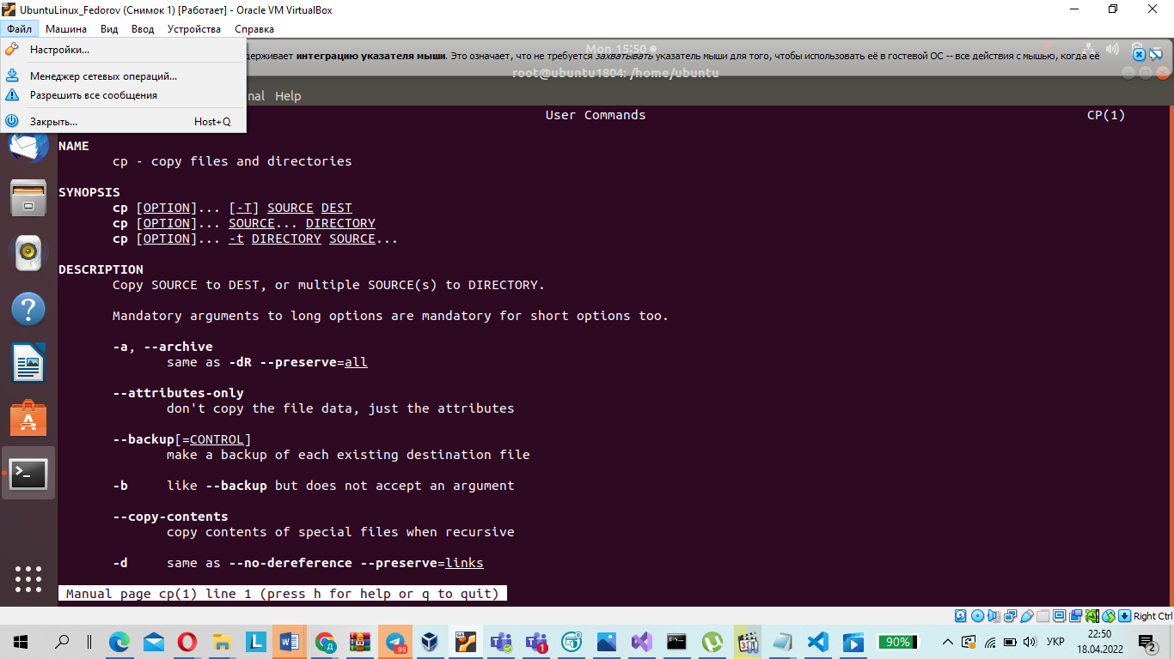

-a, --all

use all matching manuals

-h, --help

display this help and exit

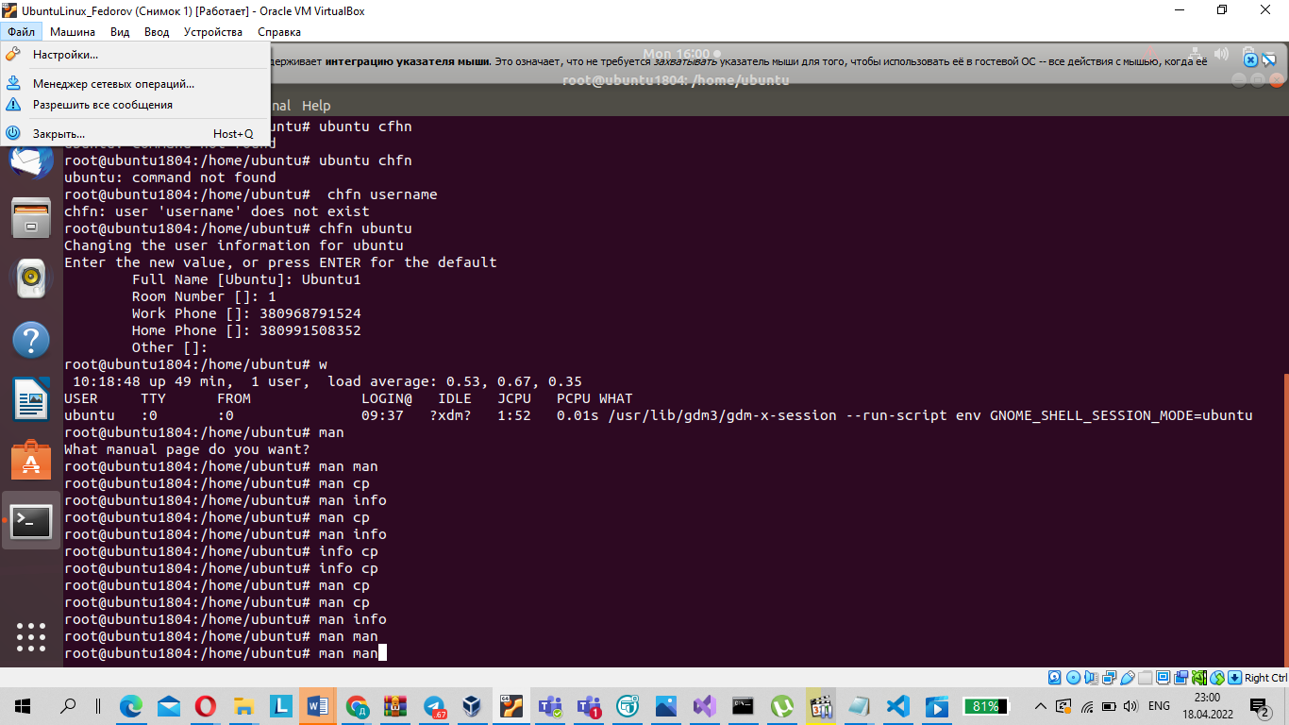

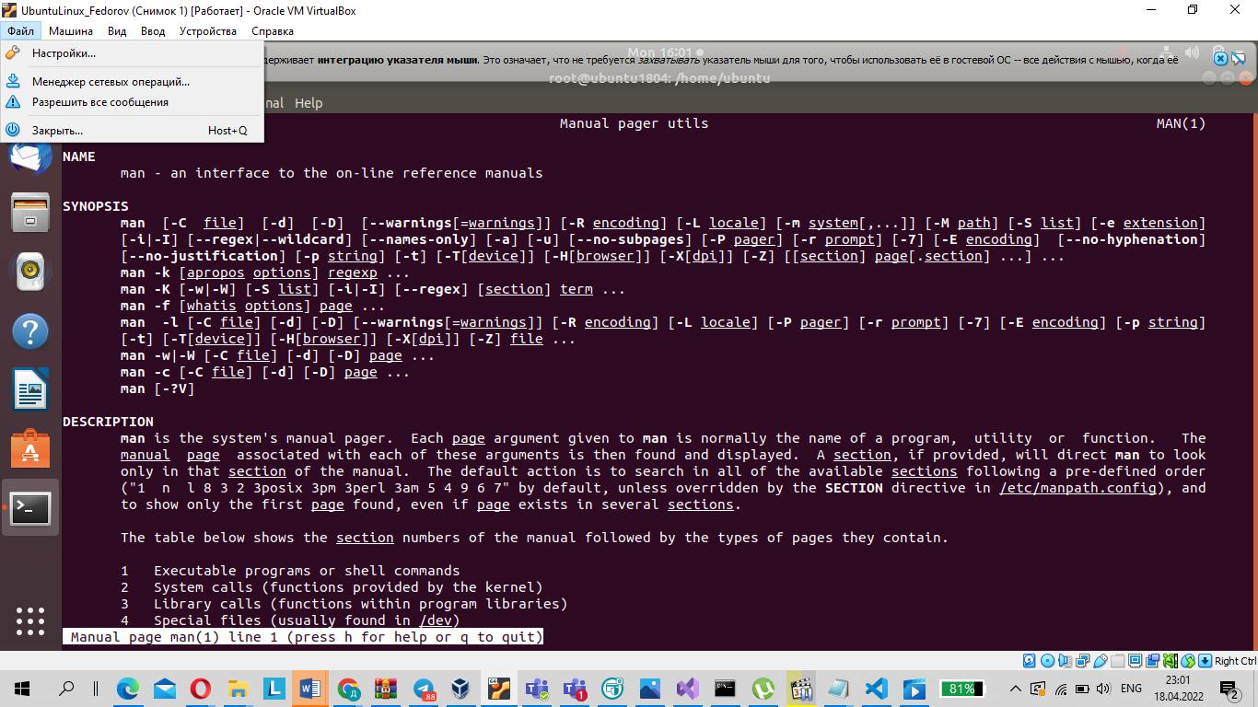

6. Explore the more and less commands using the help system. View the contents of files .bash* using commands.

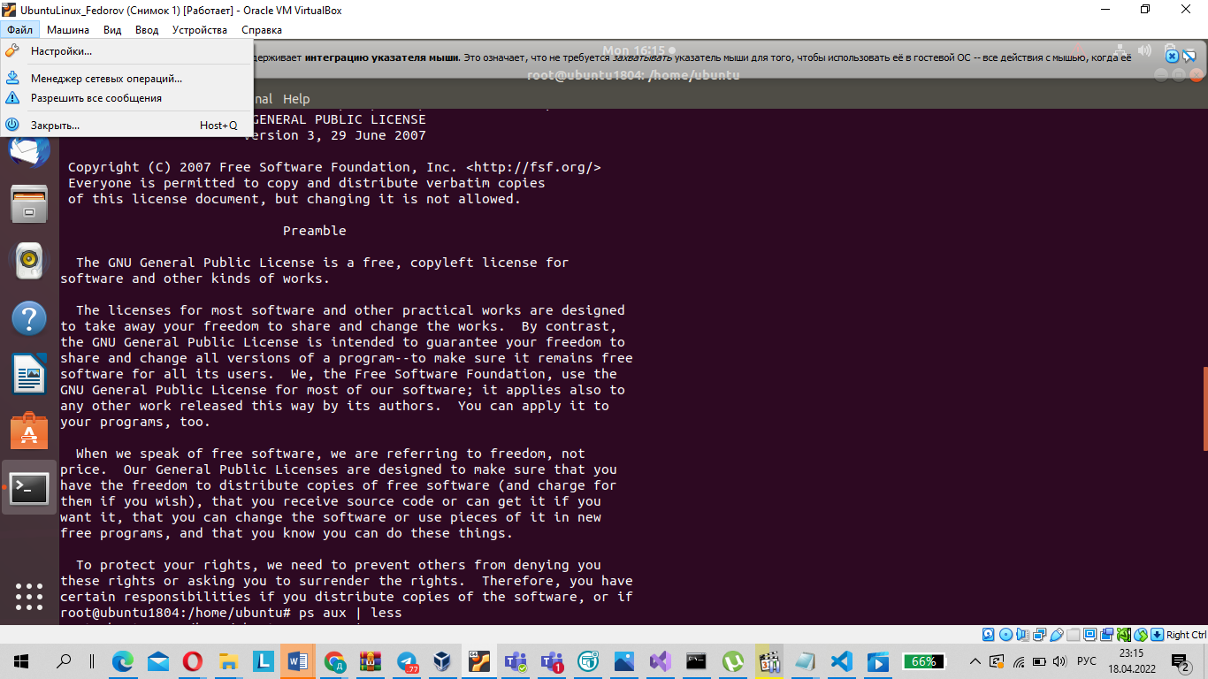

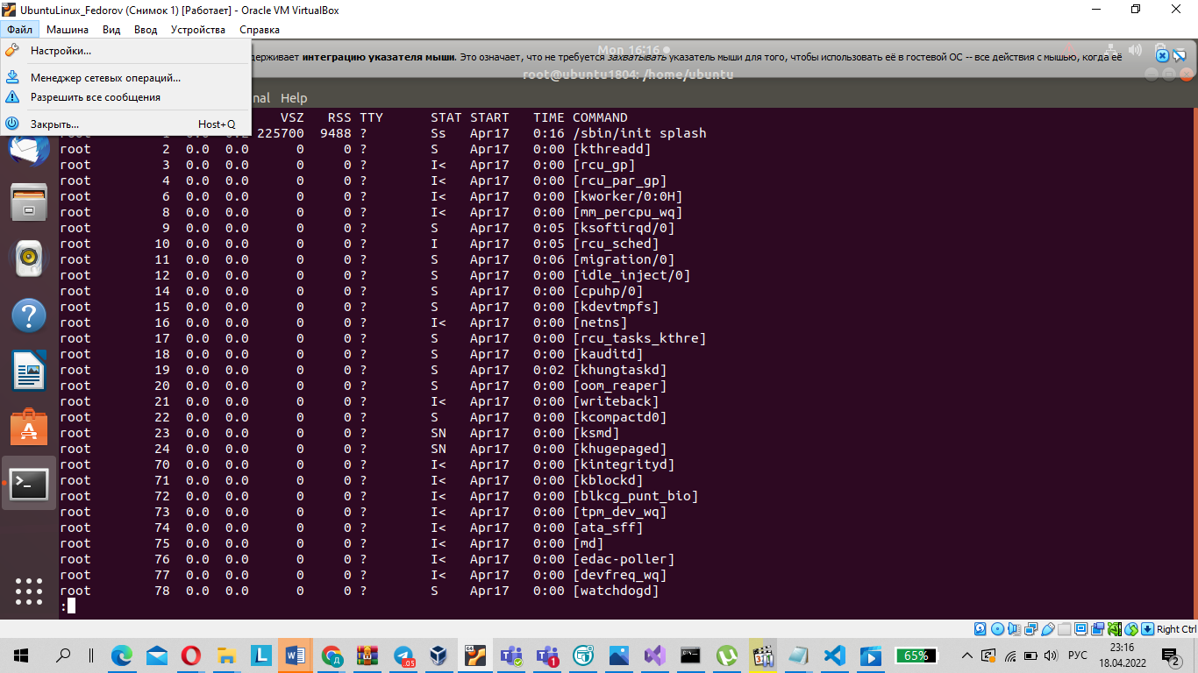

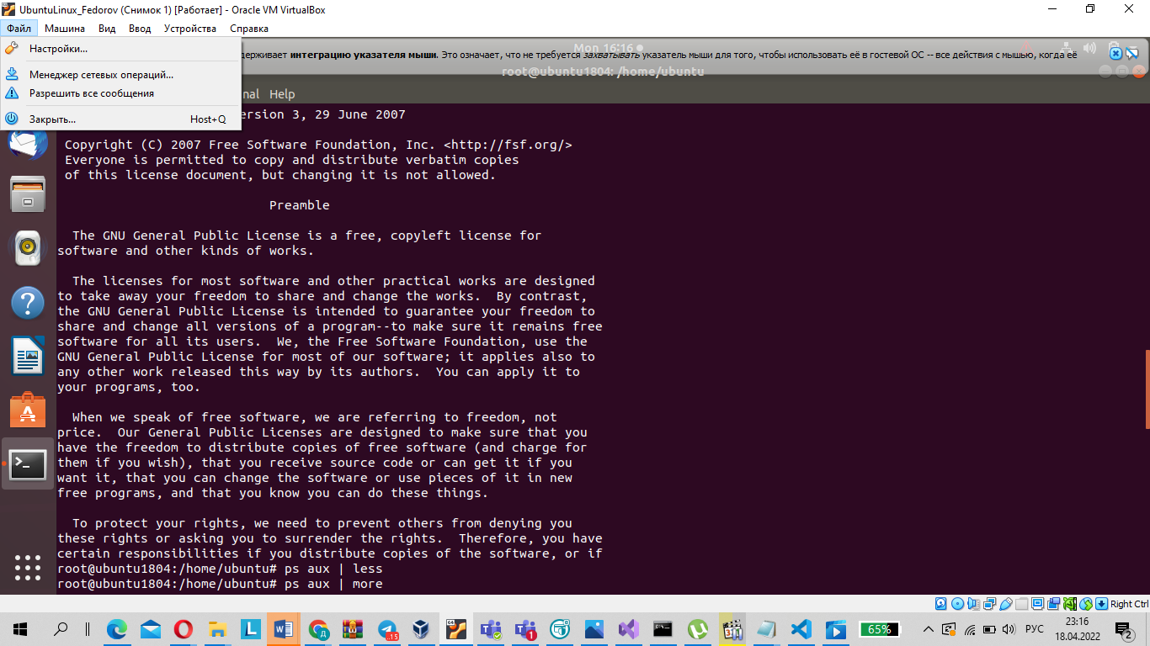

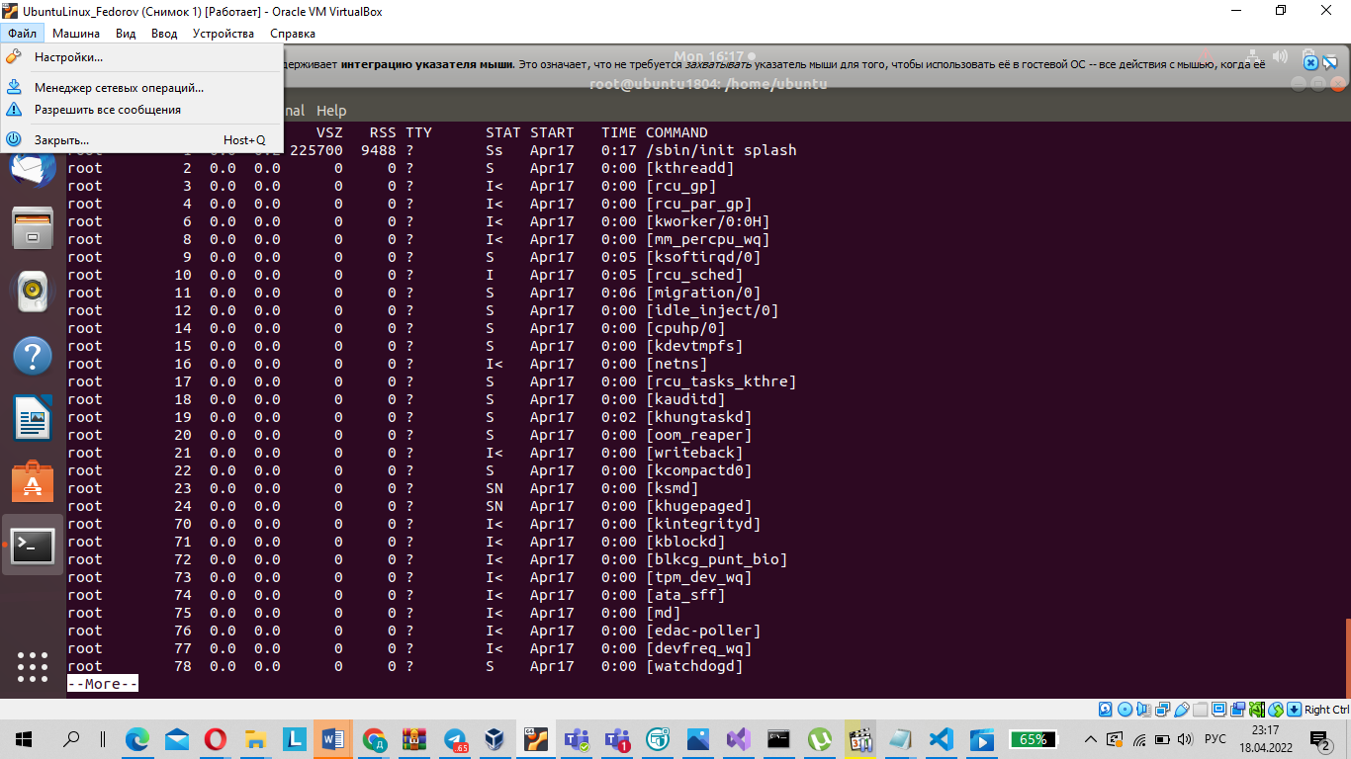

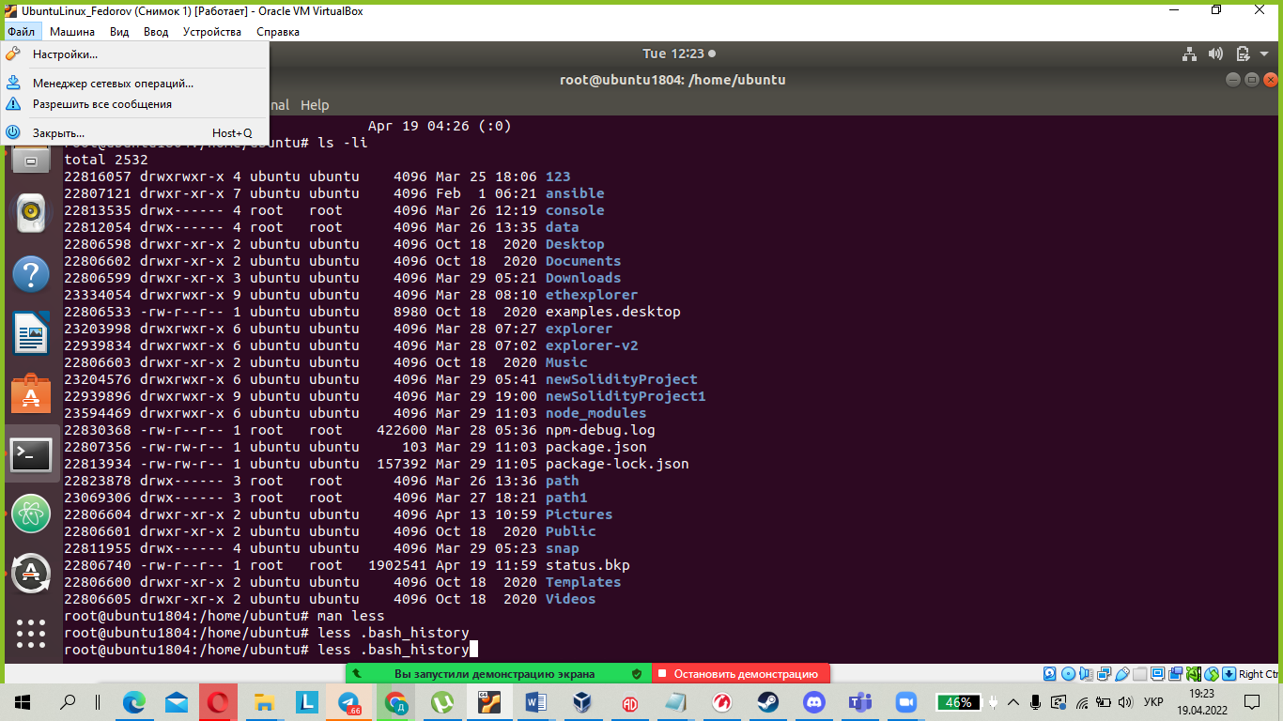

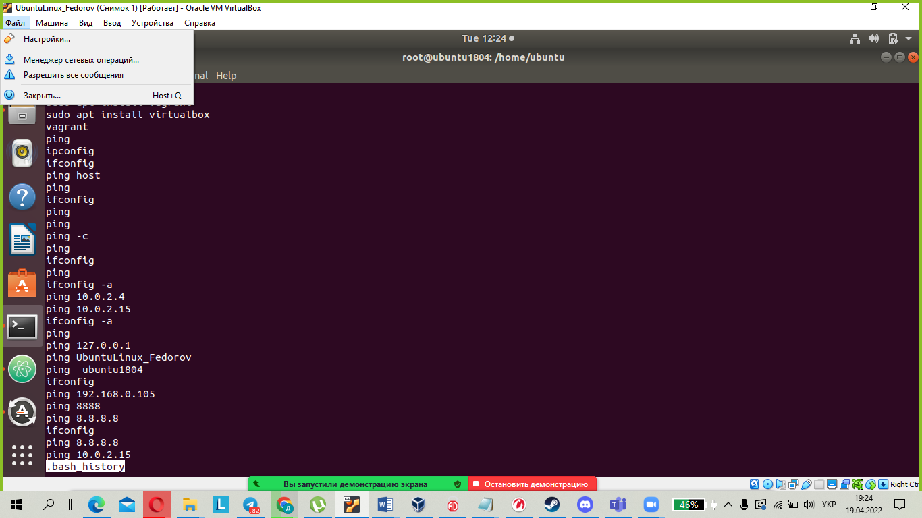

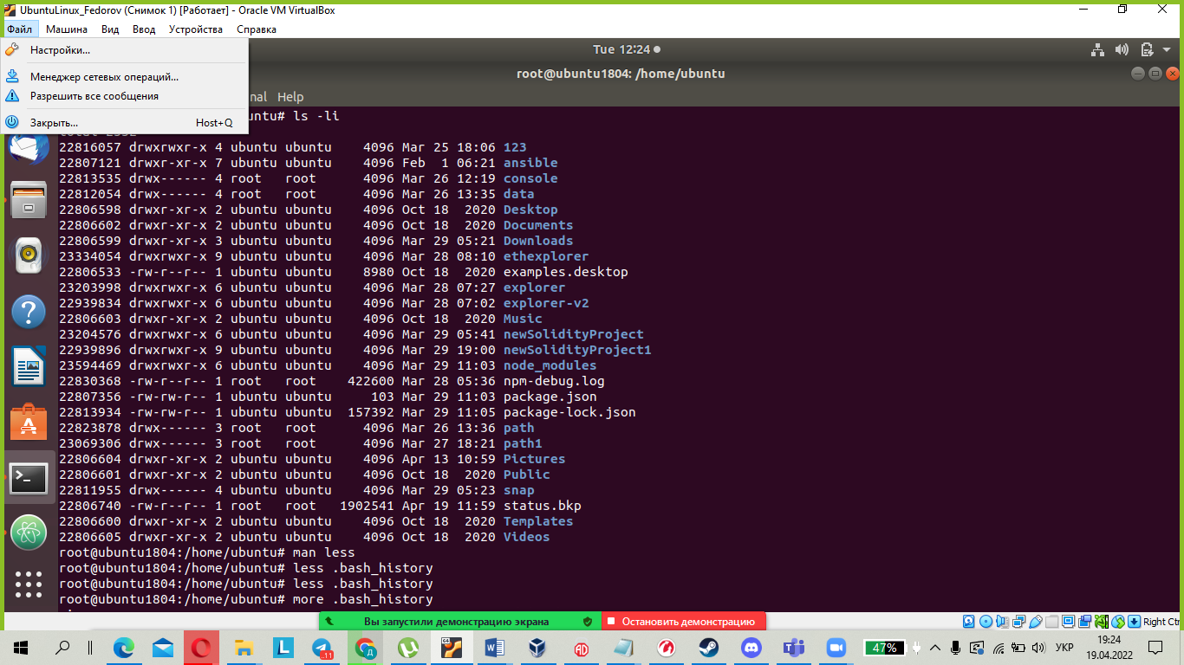

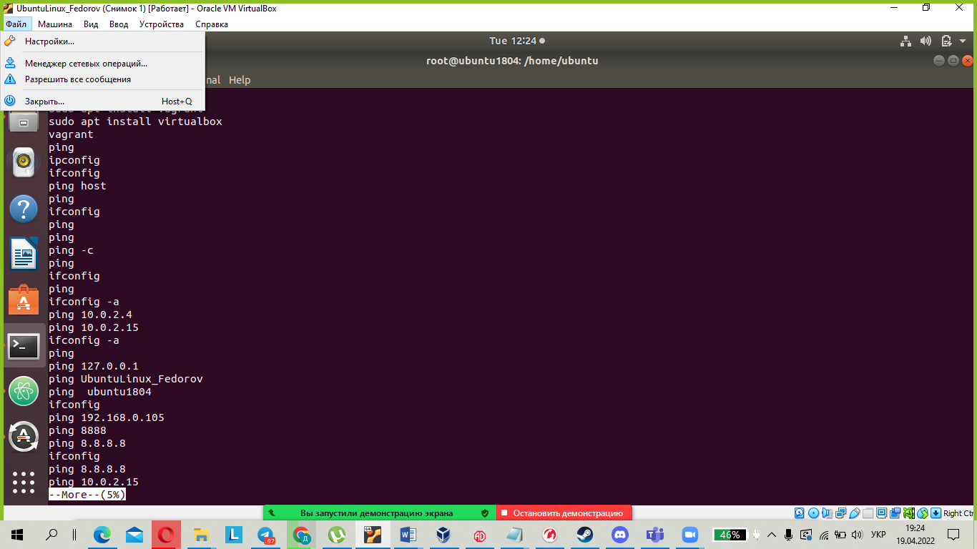

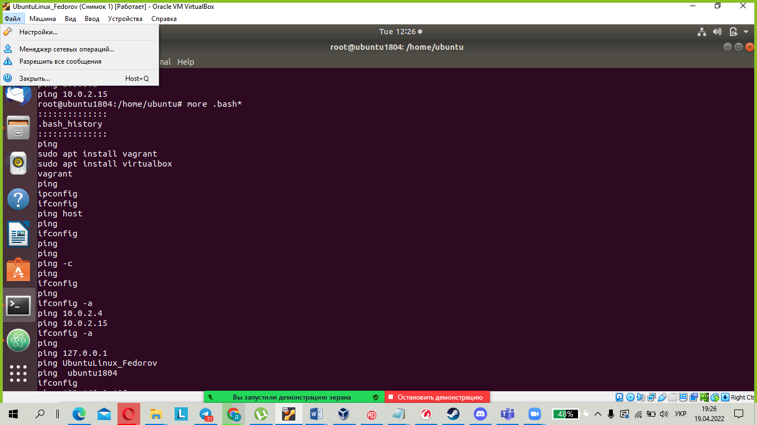

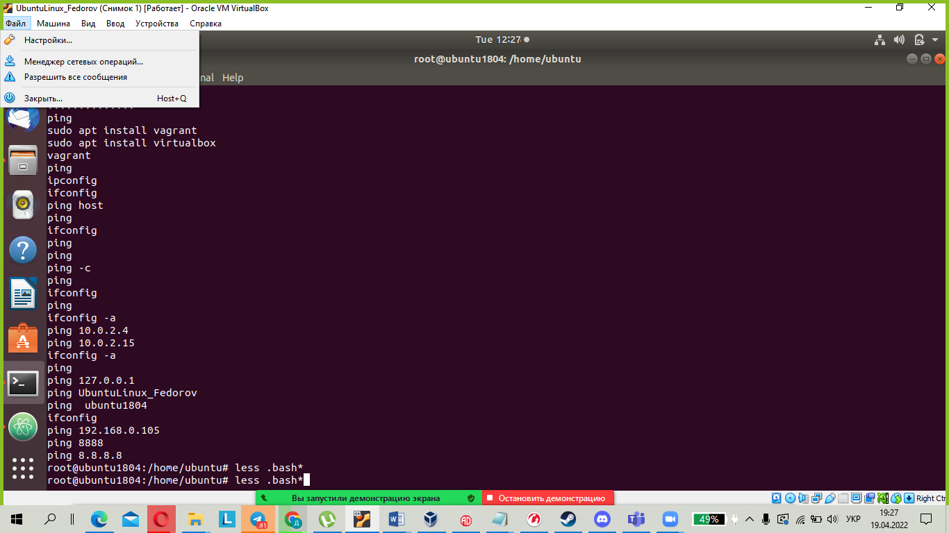

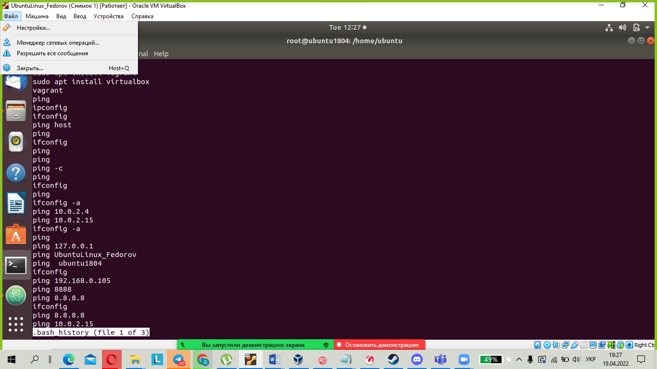

7. Describe in plans that you are working on laboratory work 1. Tip: You should read the documentation for the finger command.

man finger

info finger

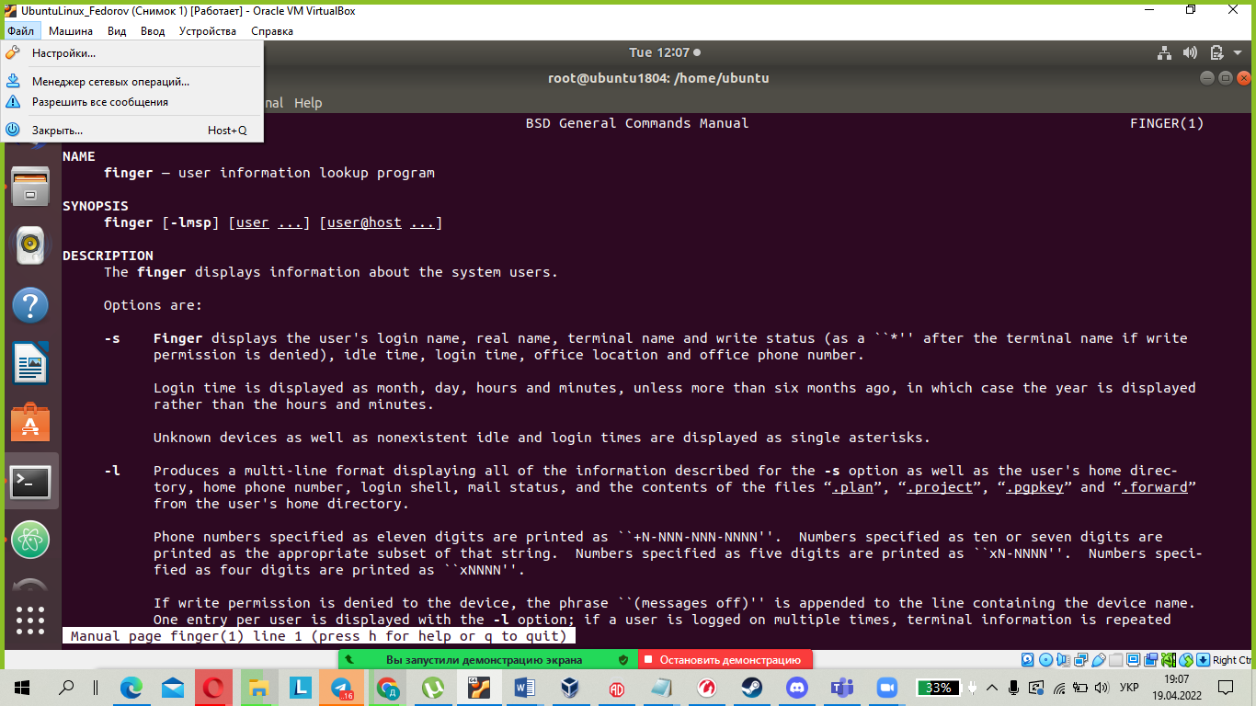

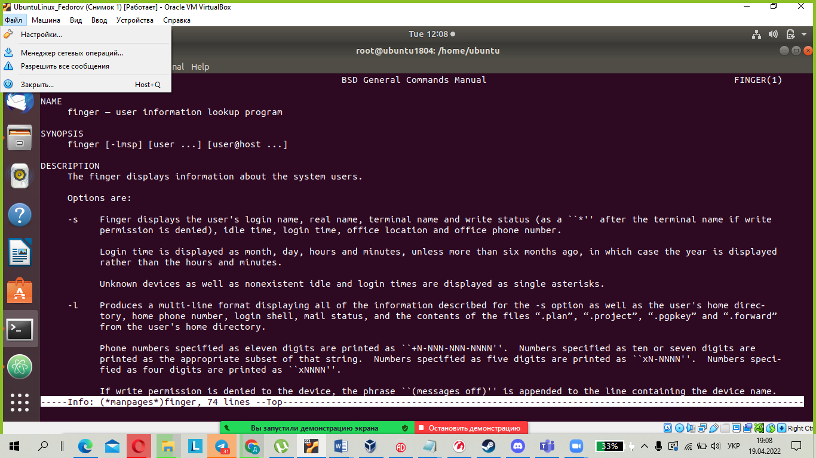

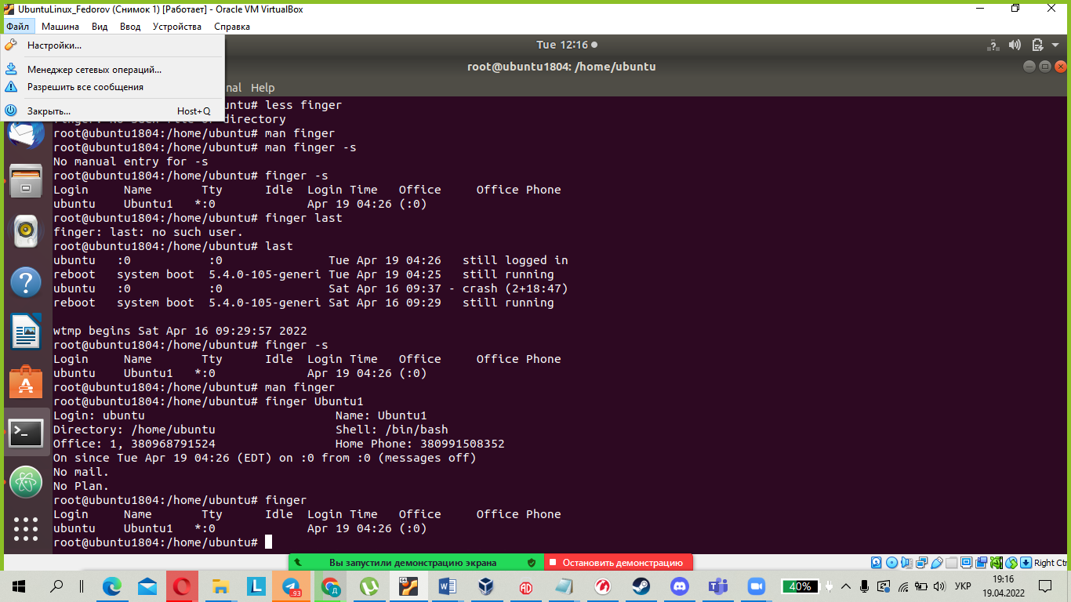

8. List the contents of the home directory using the ls command, define its files and directories. Hint: Use the help system to familiarize yourself with the ls command.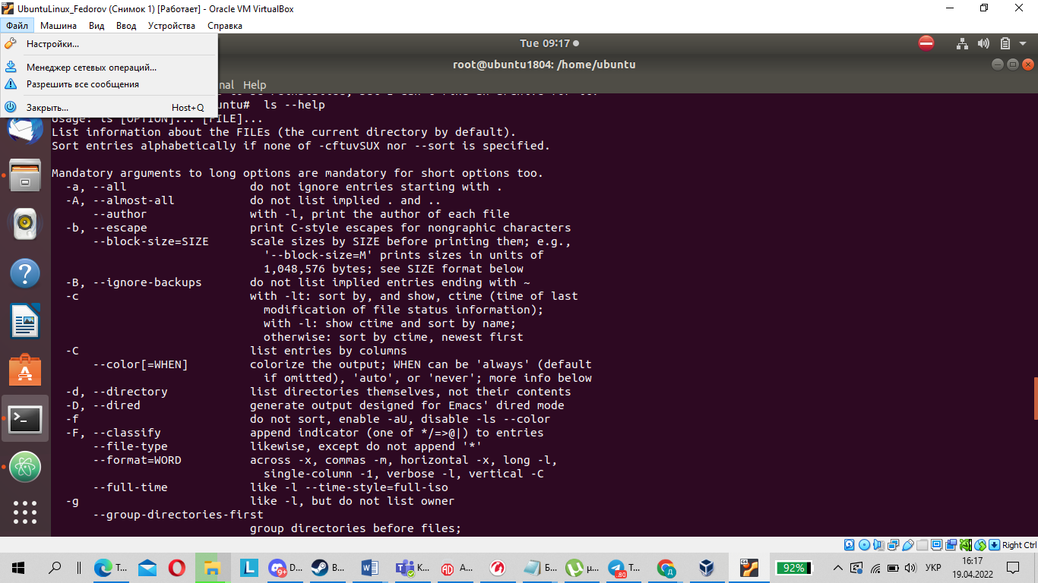

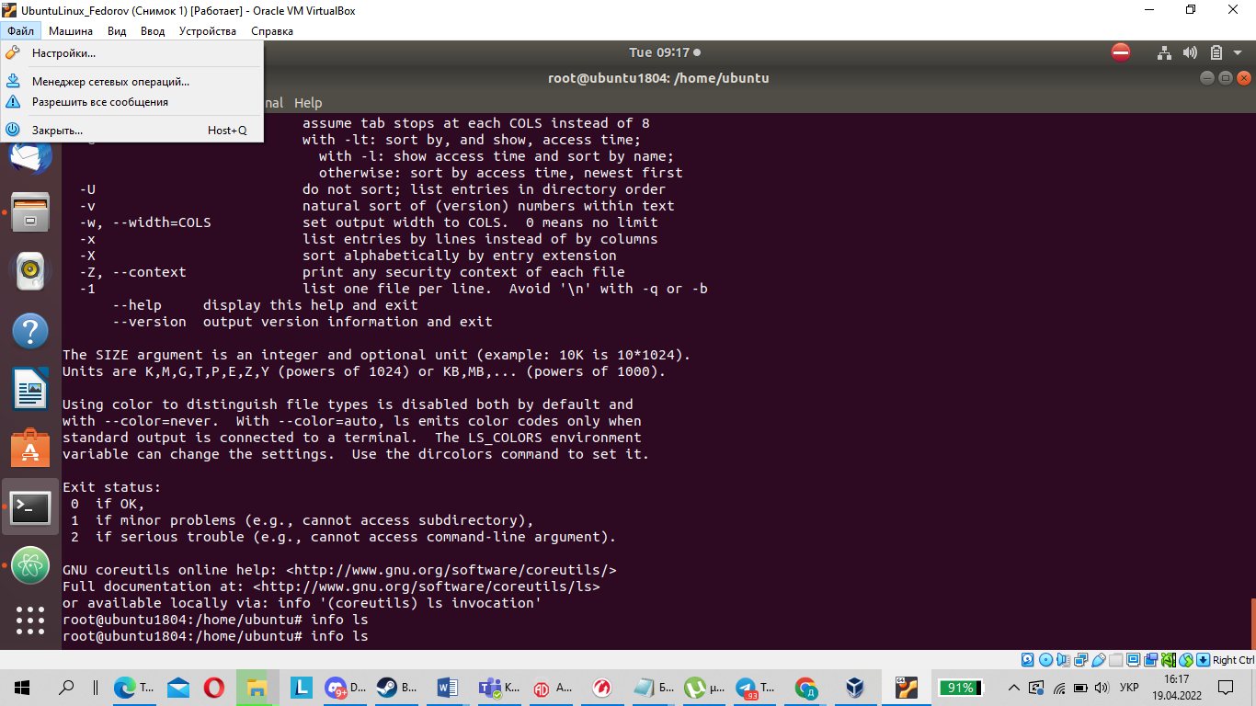

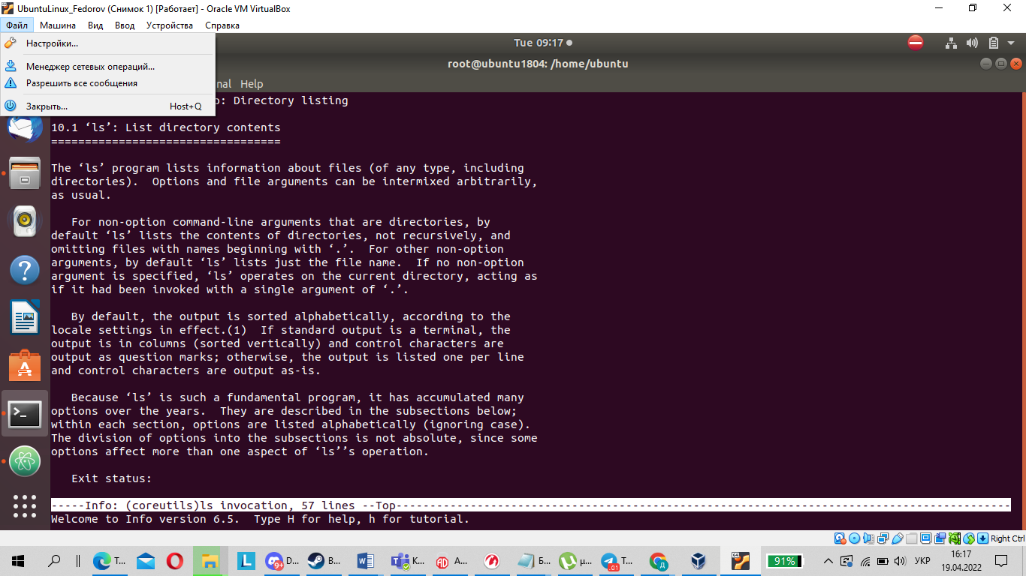

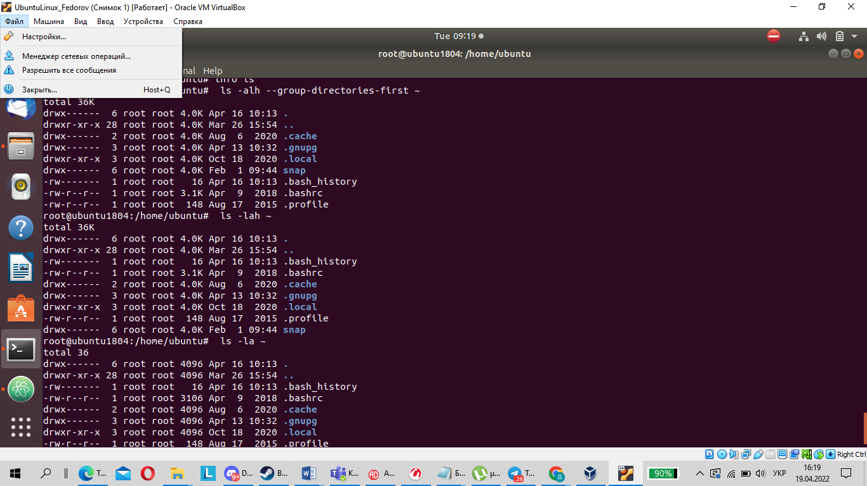

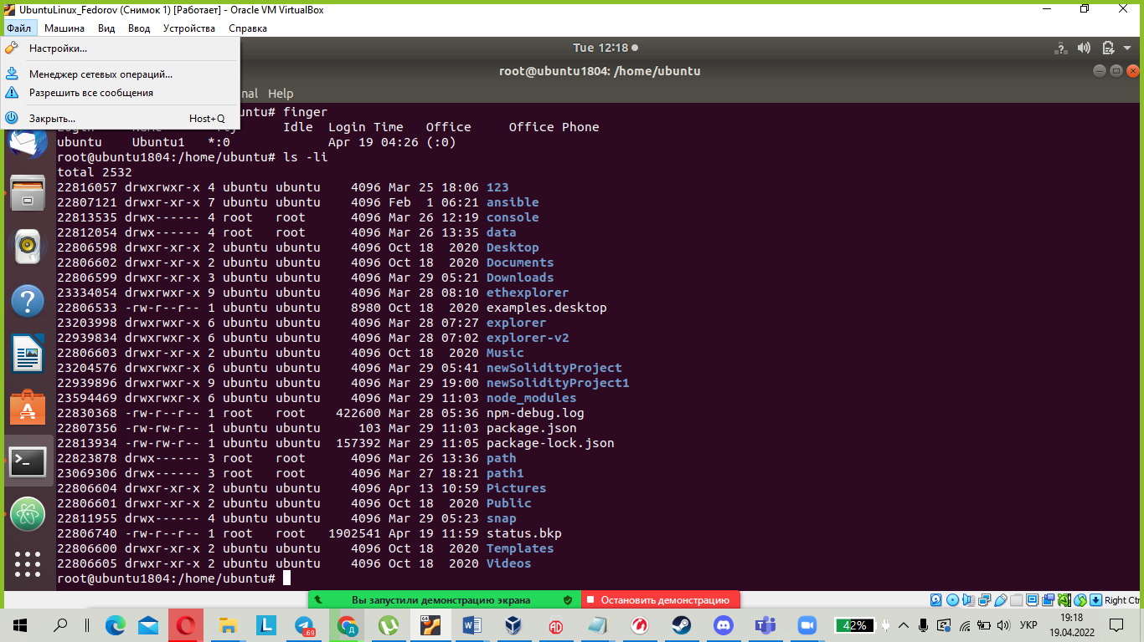

Task1 Part2

1. Examine the tree command. Master the technique of applying a template, for example, display all files that contain a character c, or files that contain a specific sequence of characters. List subdirectories of the root directory up to and including the second nesting level.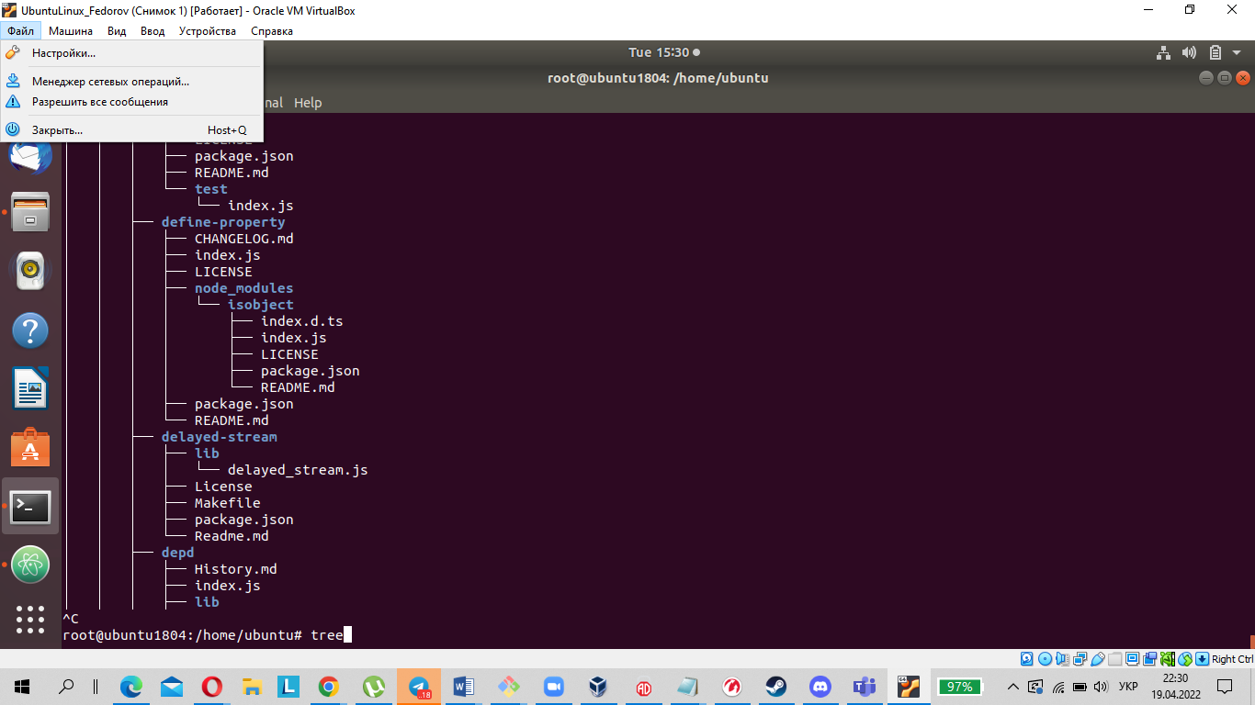

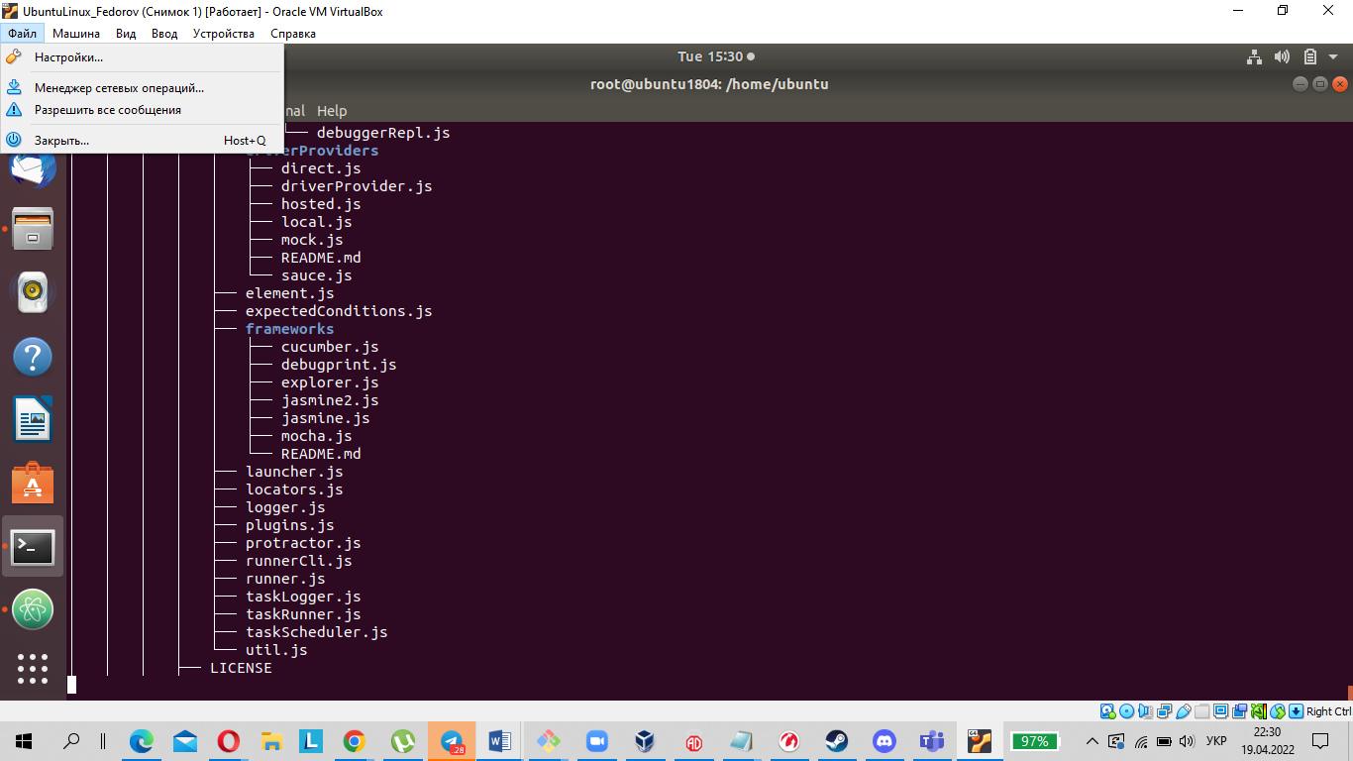

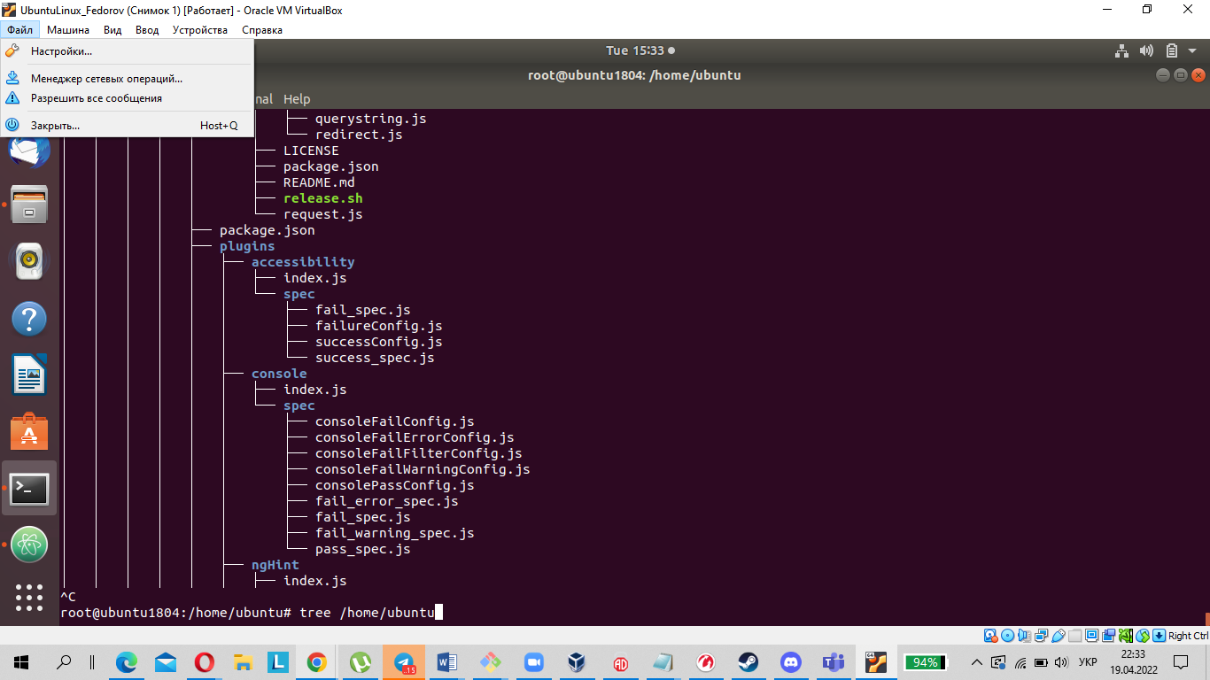

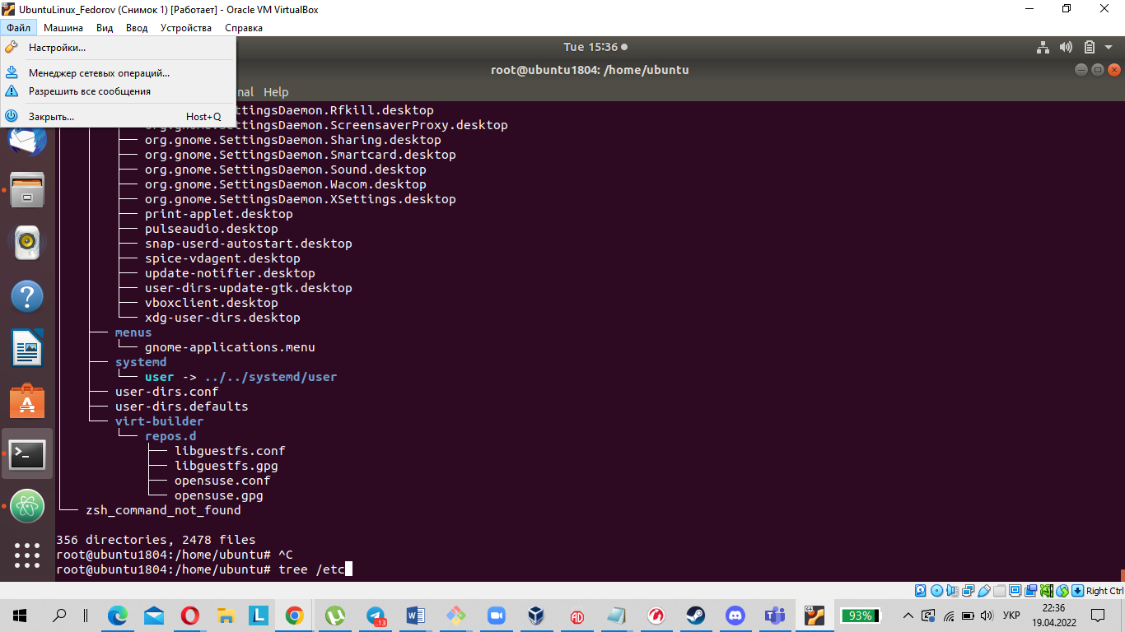

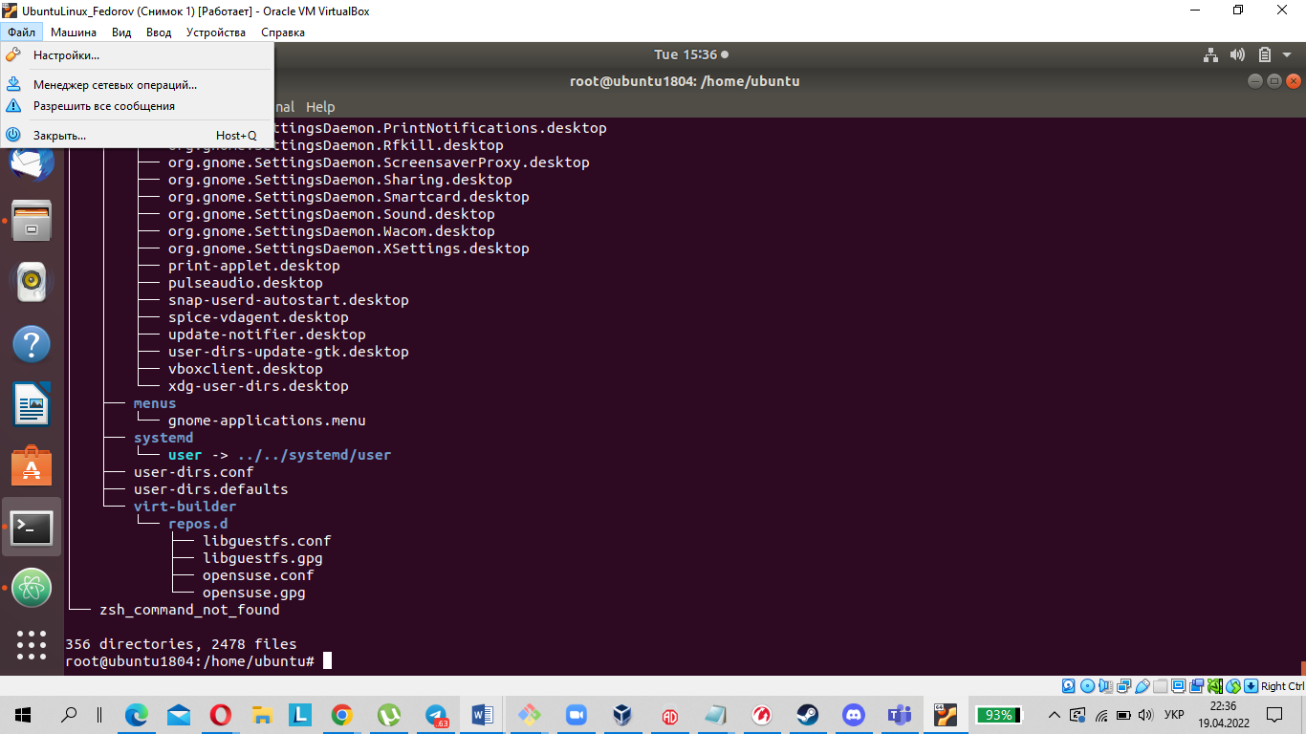

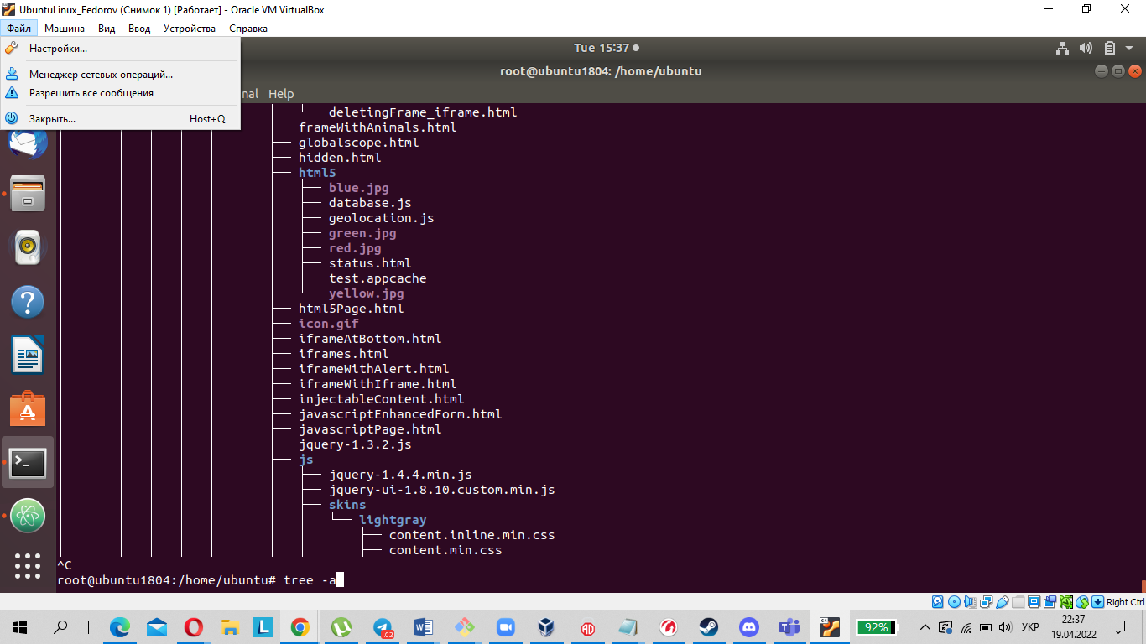

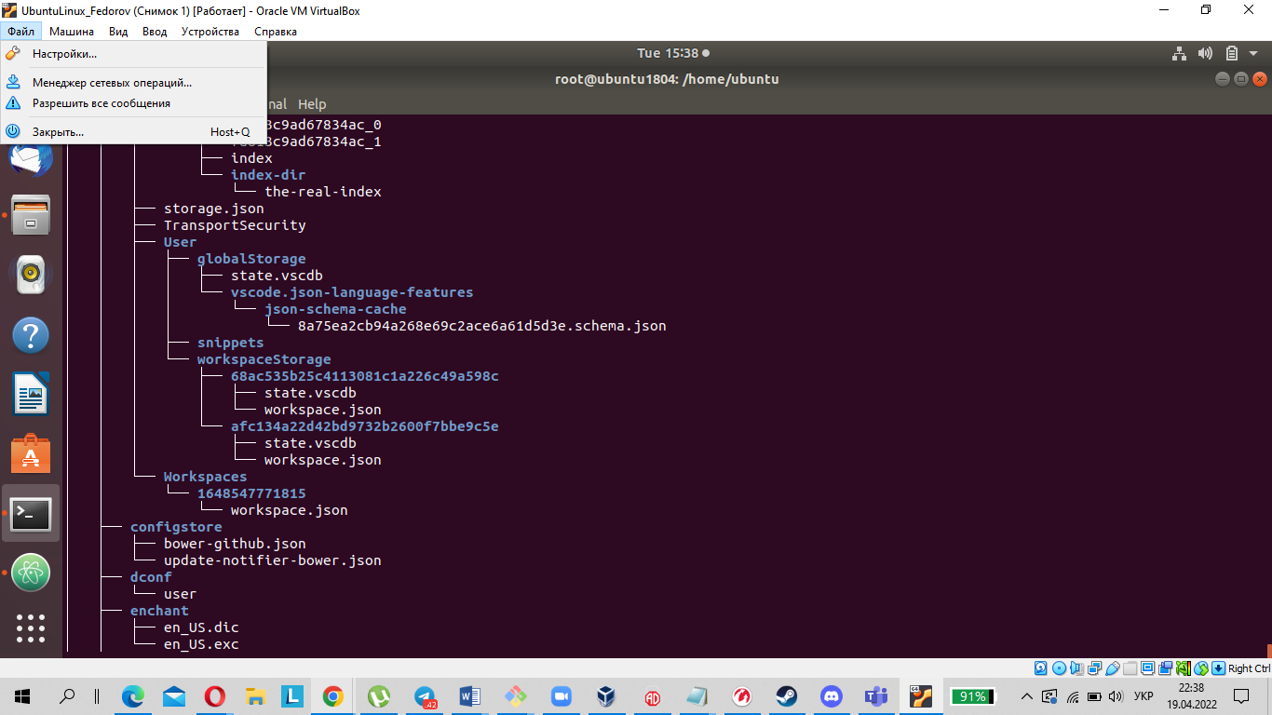

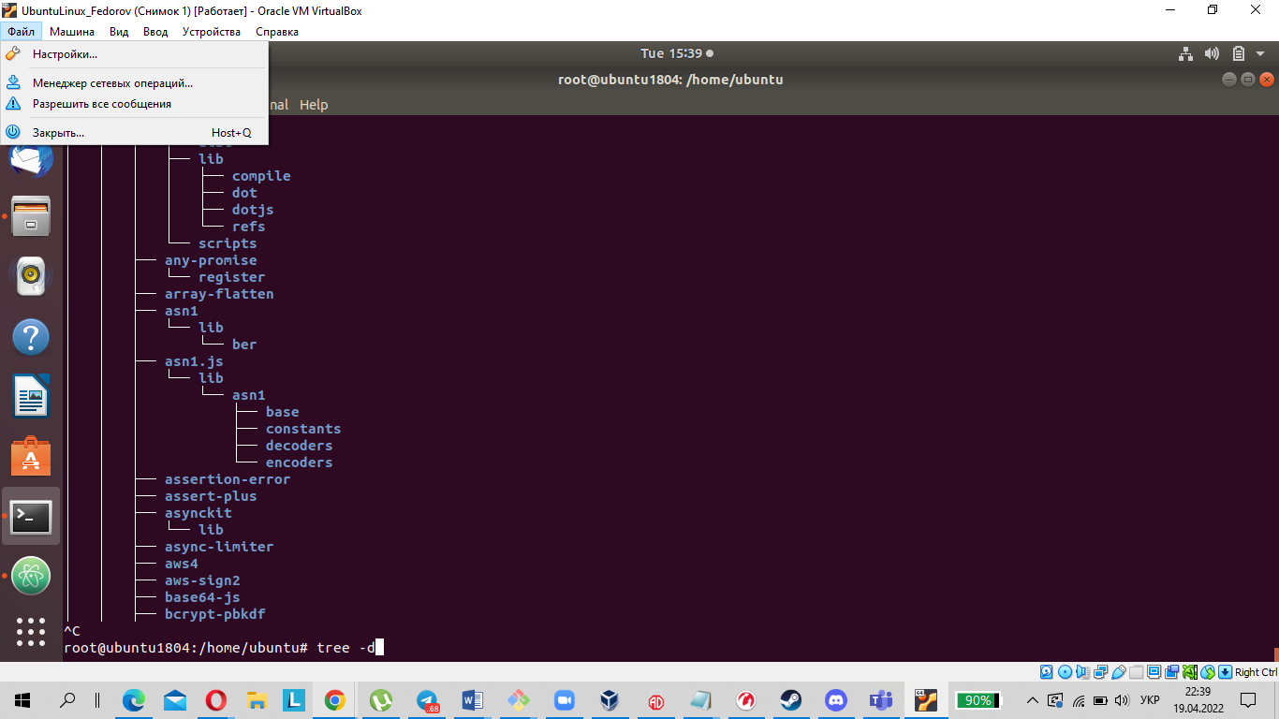

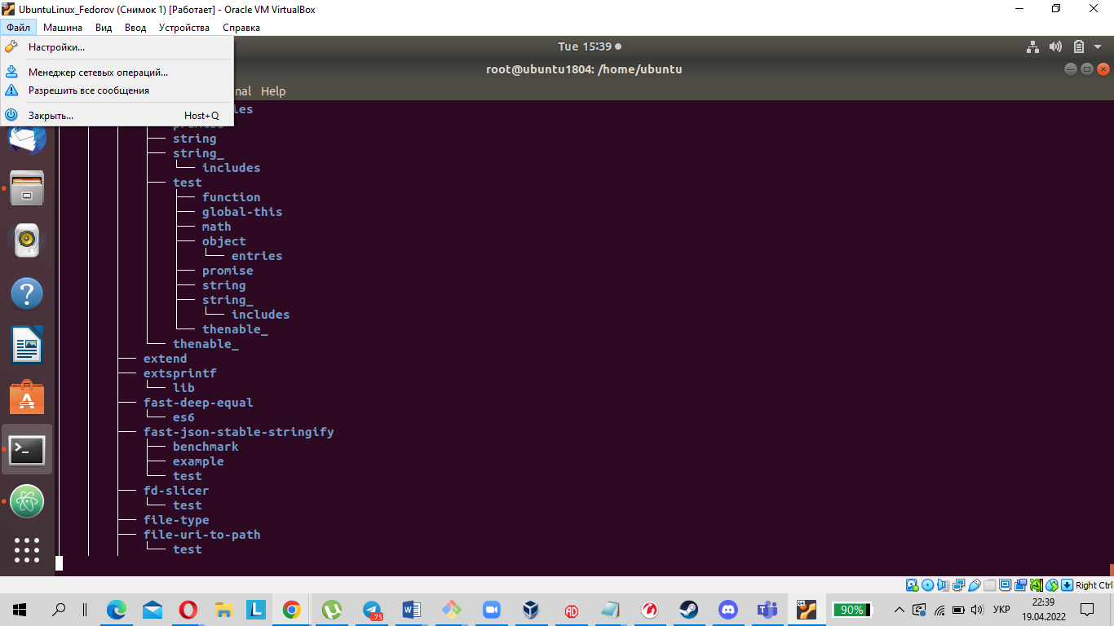

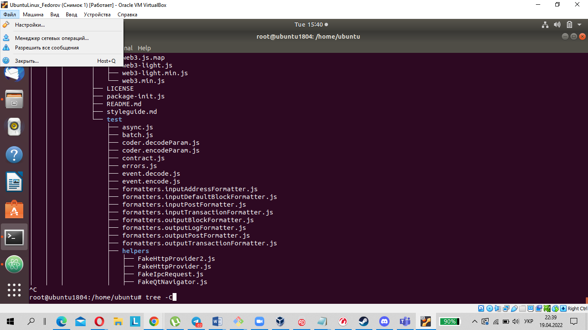

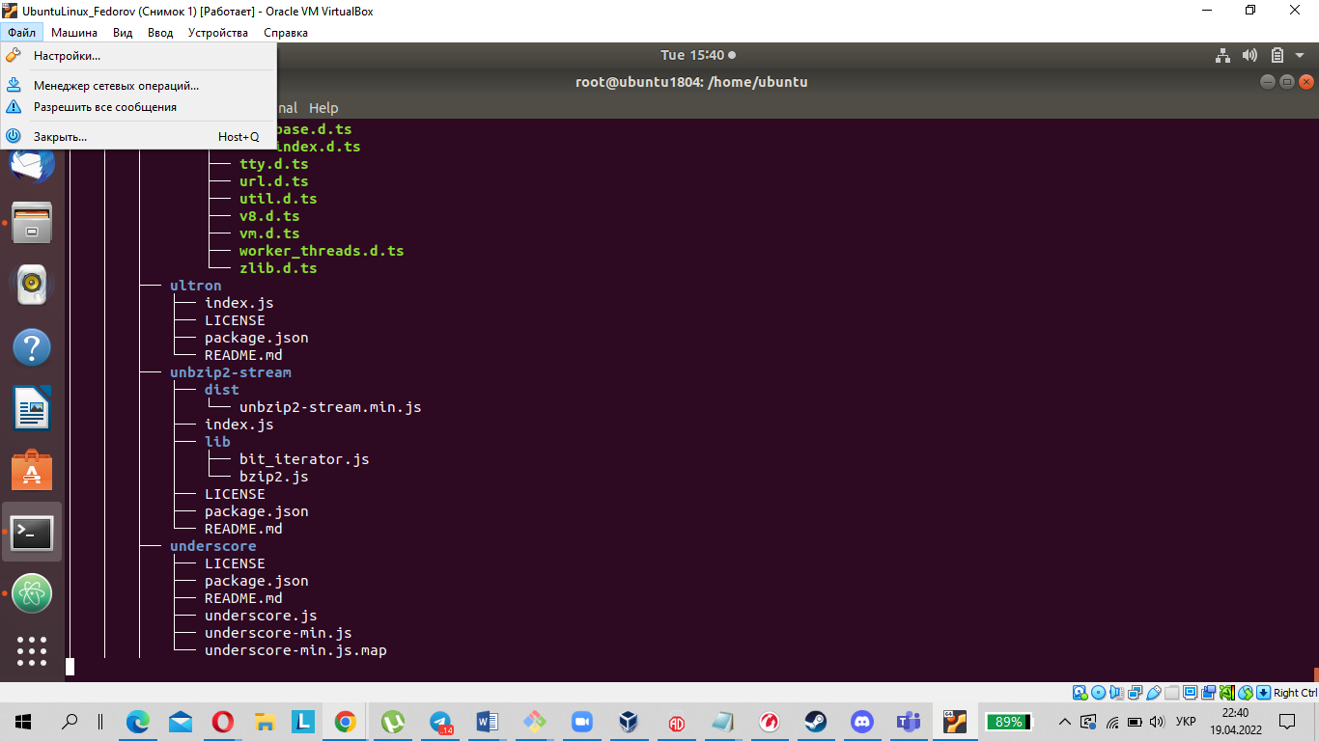

2. What command can be used to determine the type of file (for example, text or binary)? Give an example.

file [option] [filename]

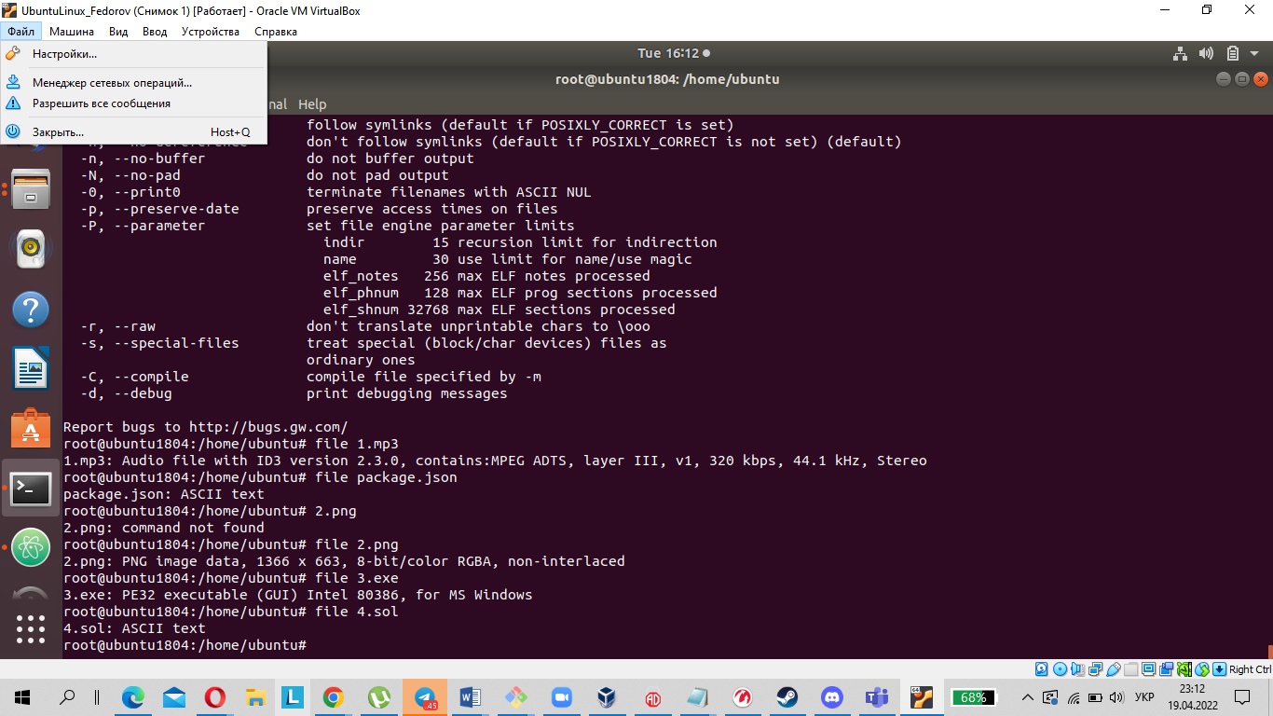

1. Master the skills of navigating the file system using relative and absolute paths. How can you go back to your home directory from anywhere in the filesystem?

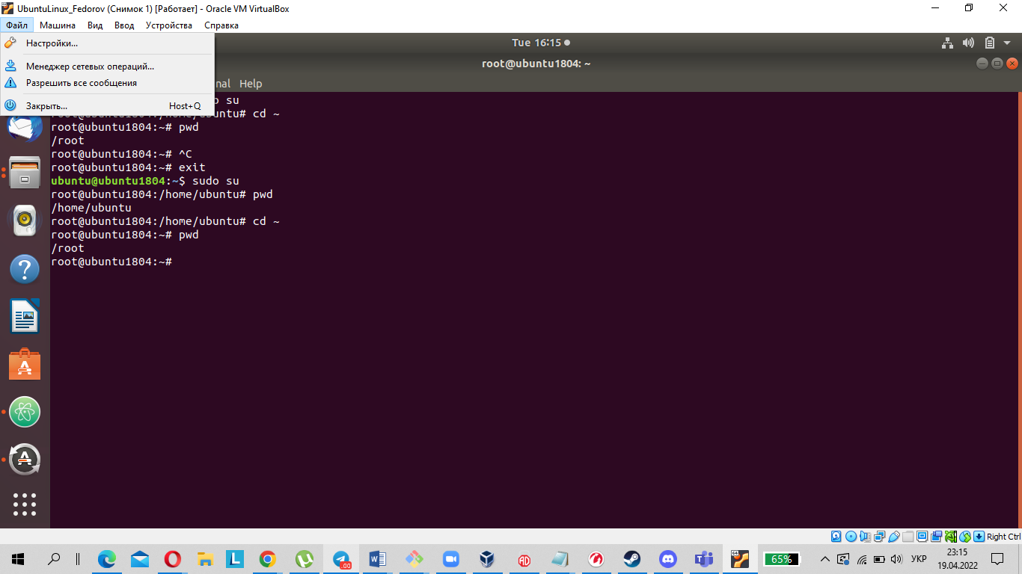

1. Become familiar with the various options for the ls command. Give examples of listing directories using different keys. Explain the information displayed on the terminal using the -l and -a switches.

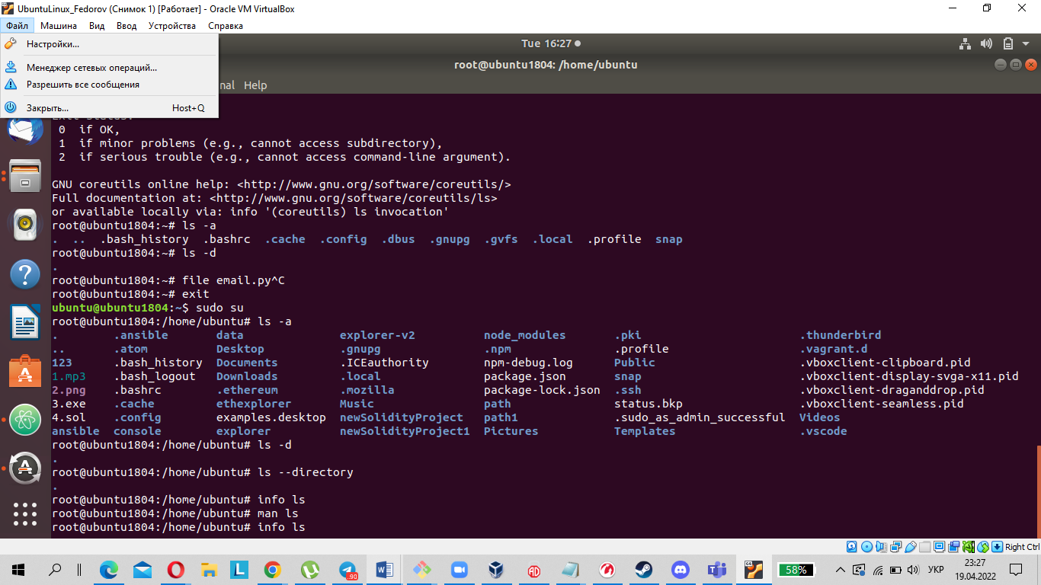

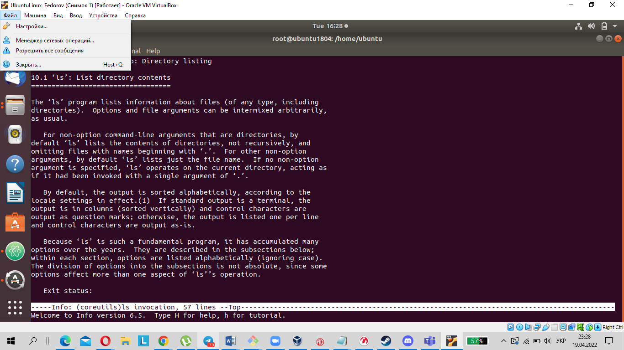

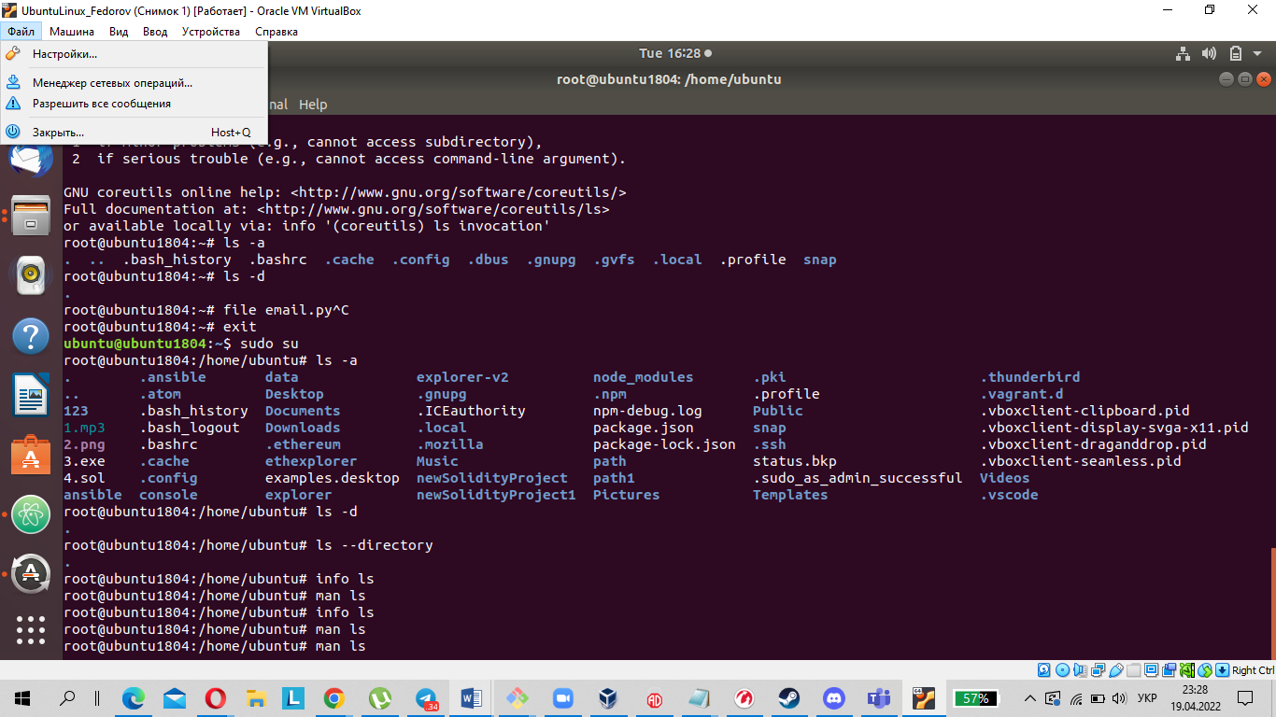

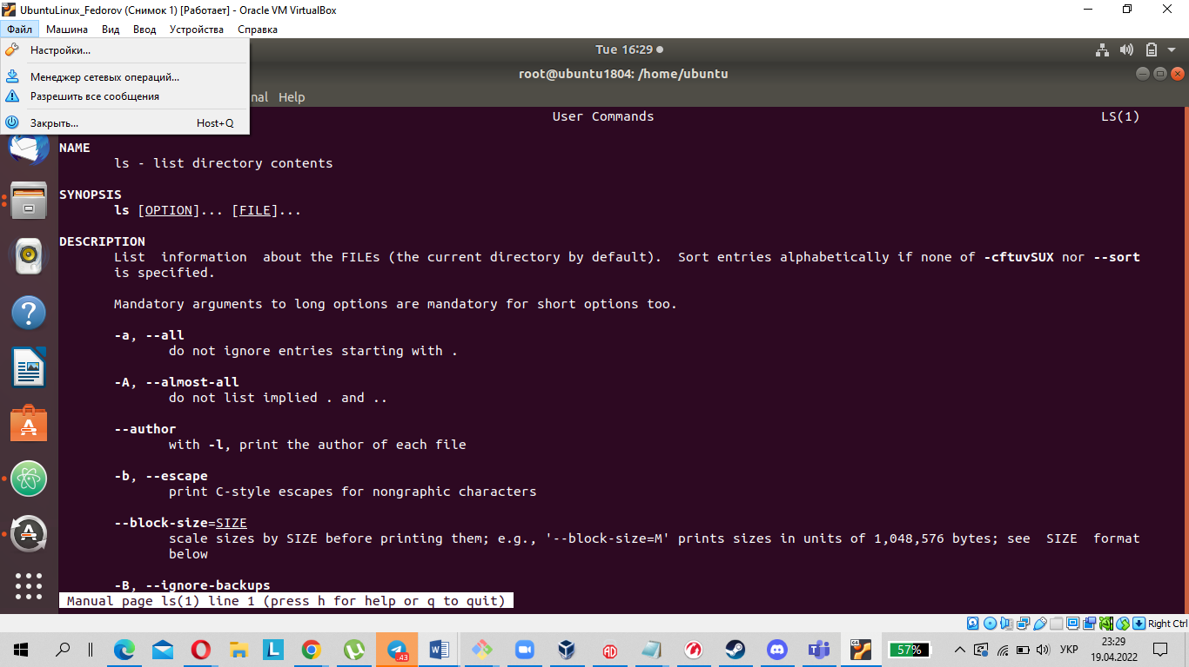

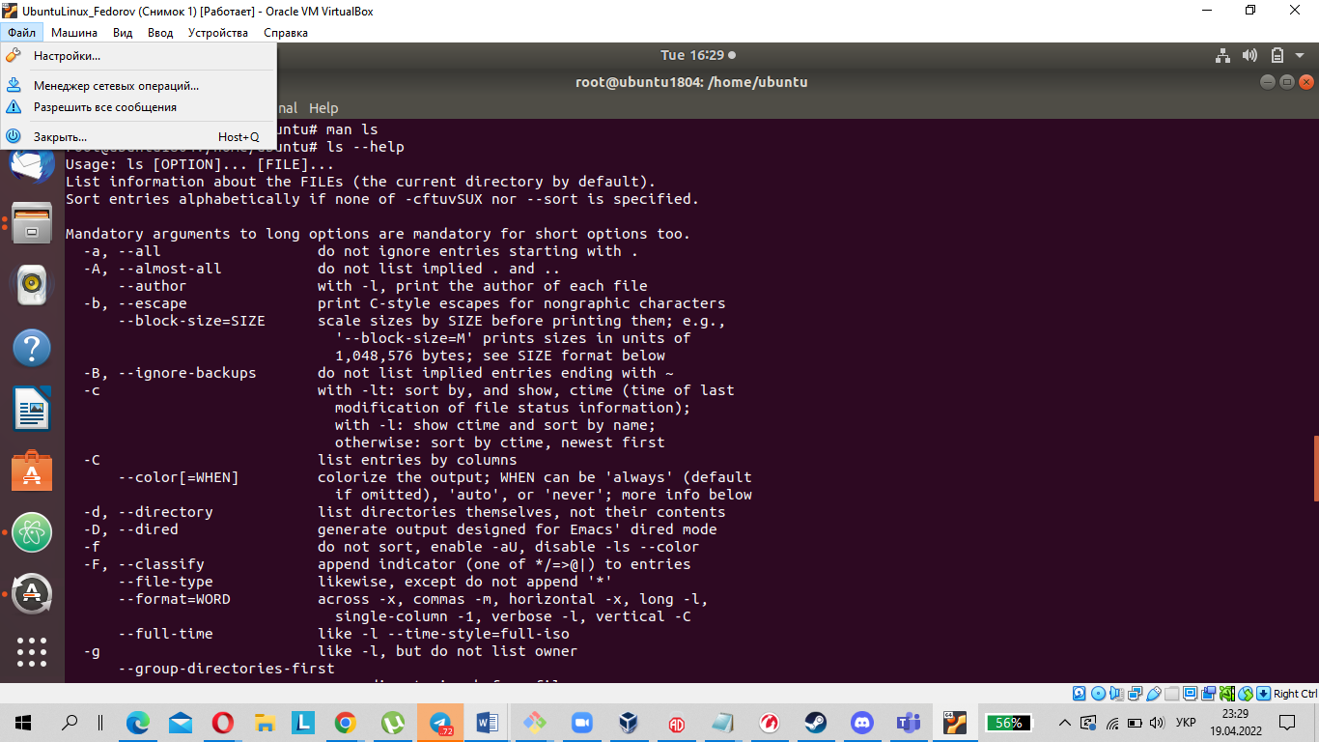

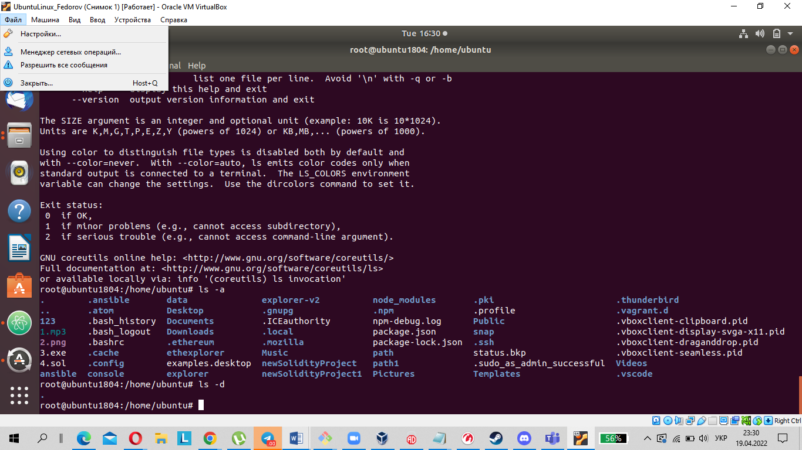

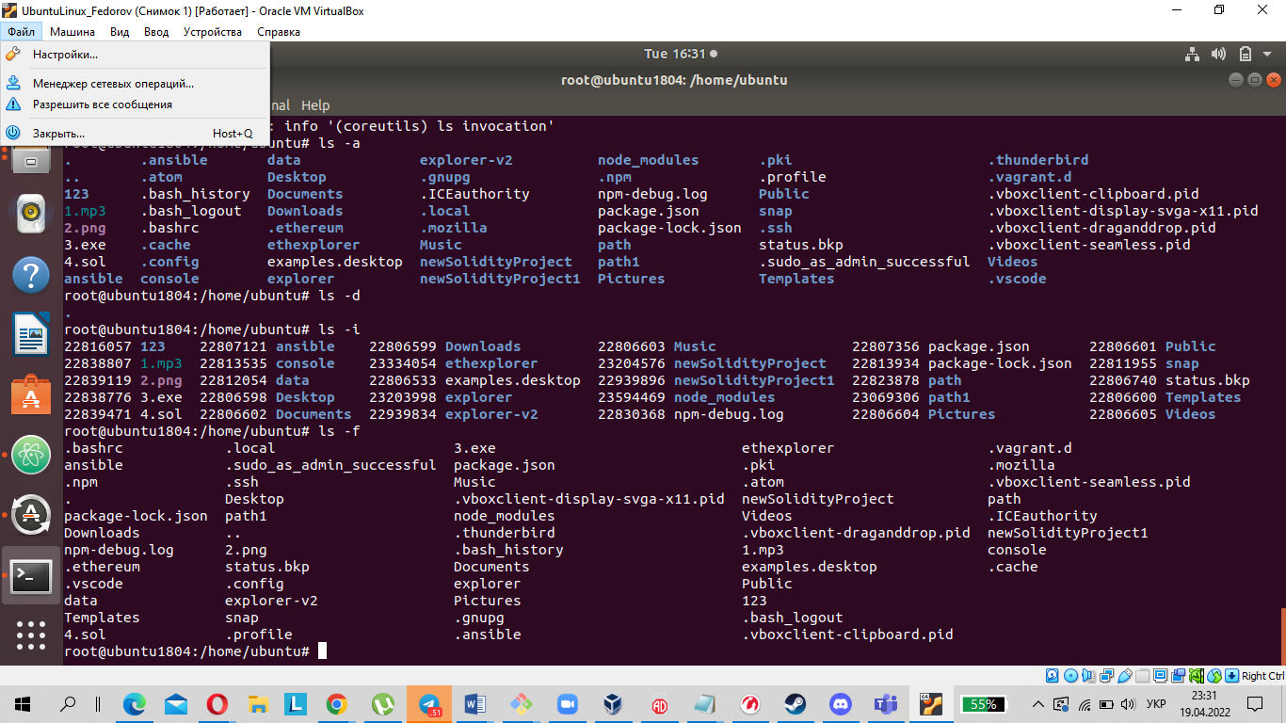

The -a, --all outputs records starting with ' '.

-d Outputting only directories, without their contents, is useful for recursive output.

5. Perform the following sequence of operations:

create a subdirectory in the home directory;

in this subdirectory create a file containing information about directories located in the root directory (using I/O redirection operations);

view the created file;

copy the created file to your home directory using relative and absolute addressing.

delete the previously created subdirectory with the file requesting removal;

delete the file copied to the home directory.

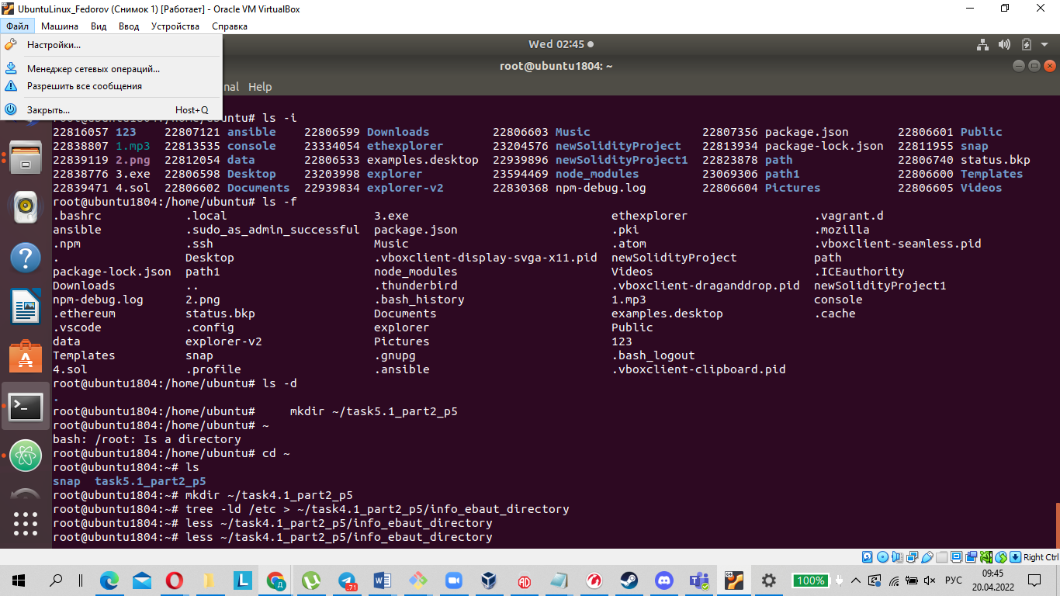

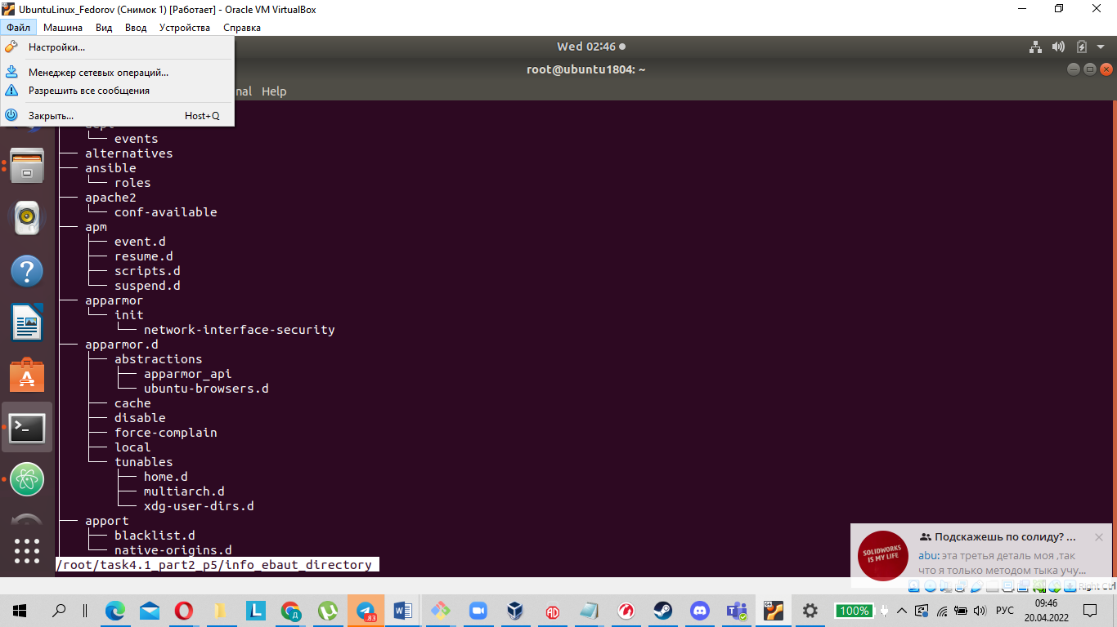

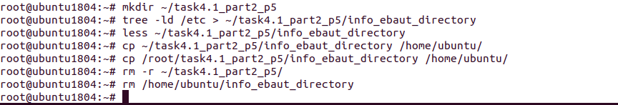

6.

6) Perform the following sequence of operations:

- create a subdirectory test in the home directory;

- copy the .bash_history file to this directory while changing its name to

labwork2;

- create a hard and soft link to the labwork2 file in the test subdirectory;

- how to define soft and hard link, what do these concepts;

A hard link creates another entry in the file system which refers to the same data area on the disk as the original file. Since a file is a named area on the disk, a hard link can be said to simply define another name for an already named area. All such references, including the original file name, are treated by the system as synonyms, and the file itself is not deleted as long as it has at least one name.

ln -P <Source> <Target>

A soft link or symbolic link creates a pointer to the file name, not to the data area. Thus, if you delete a file, the symbolic links, while still in the file system, become "broken".

ln -s <Source> <Target>

- change the data by opening a symbolic link. What changes will happen and why

- rename the hard link file to hard_lnk_labwork2;

- rename the soft link file to symb_lnk_labwork2 file;

- then delete the labwork2. What changes have occurred and why?

The file hard-lnk-labwork2 (which has the same descriptor as labwork2) will remain in the folder, and the file symb-lnk-labwork2 will remain with a broken link .

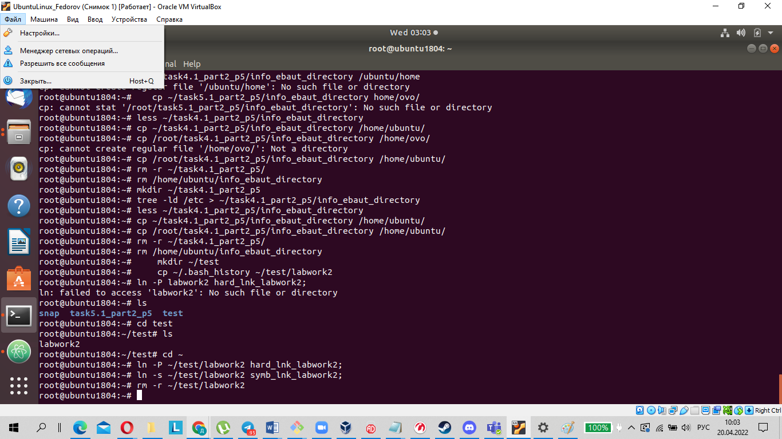

7.Using the locate utility, find all files that contain the squid and traceroute

sequence.

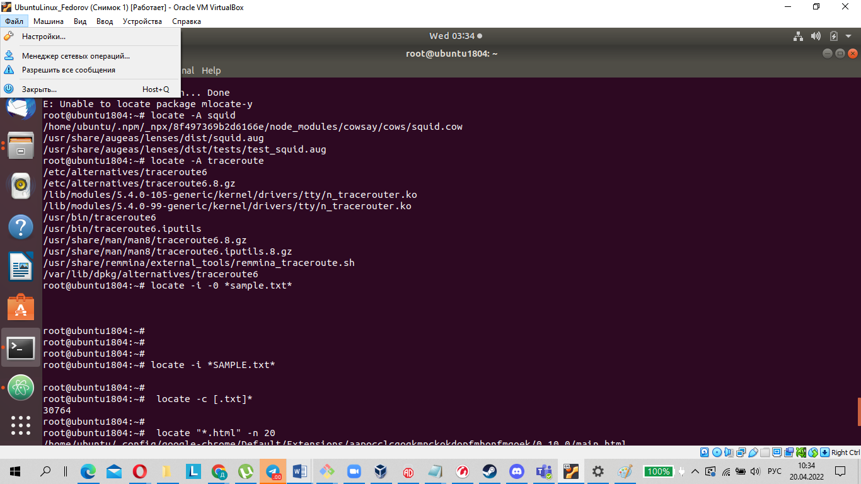

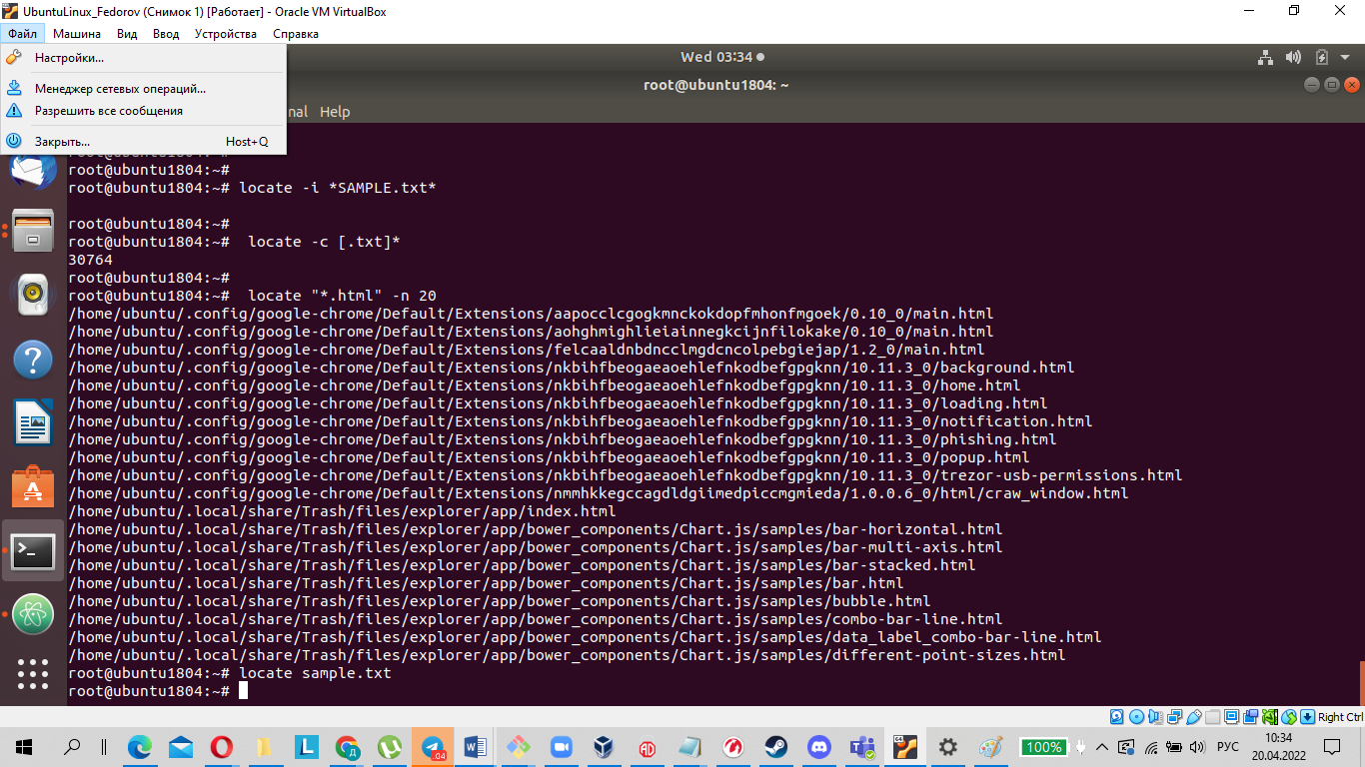

8.Determine which partitions are mounted in the system, as well as the types of

these partitions.

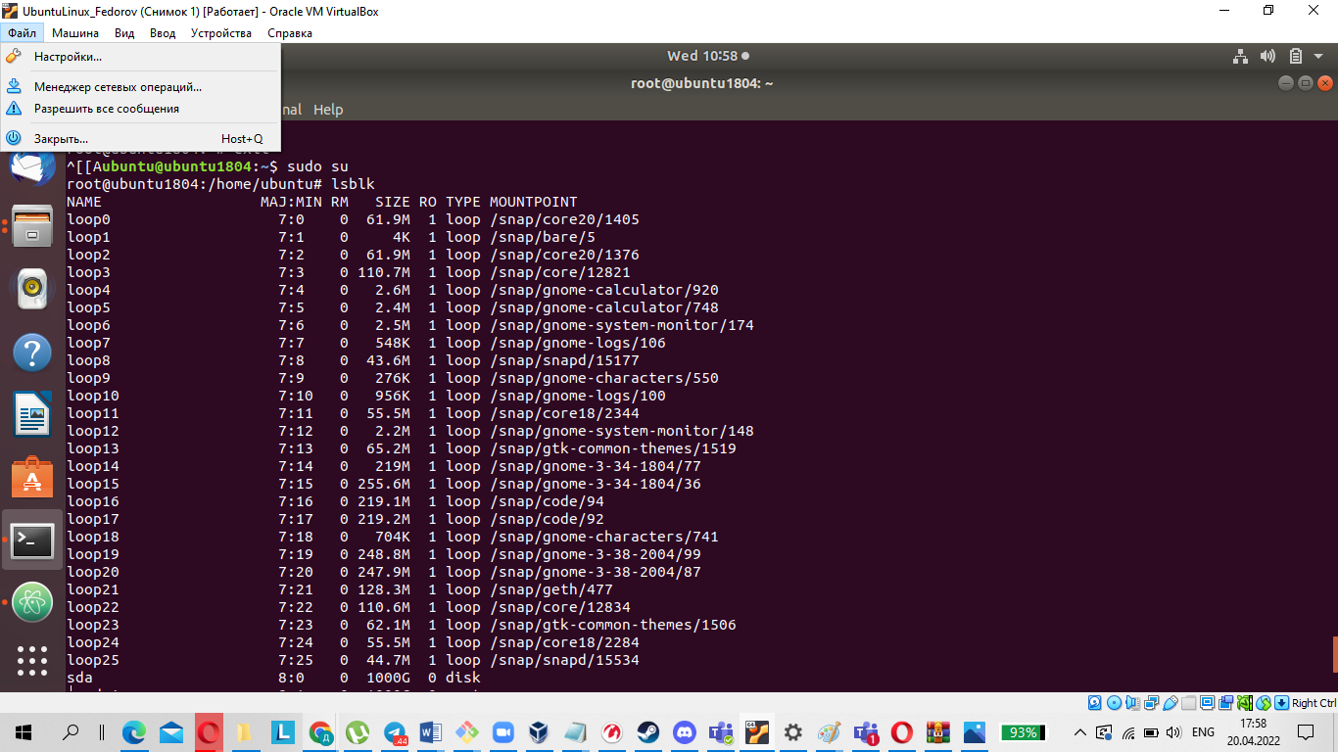

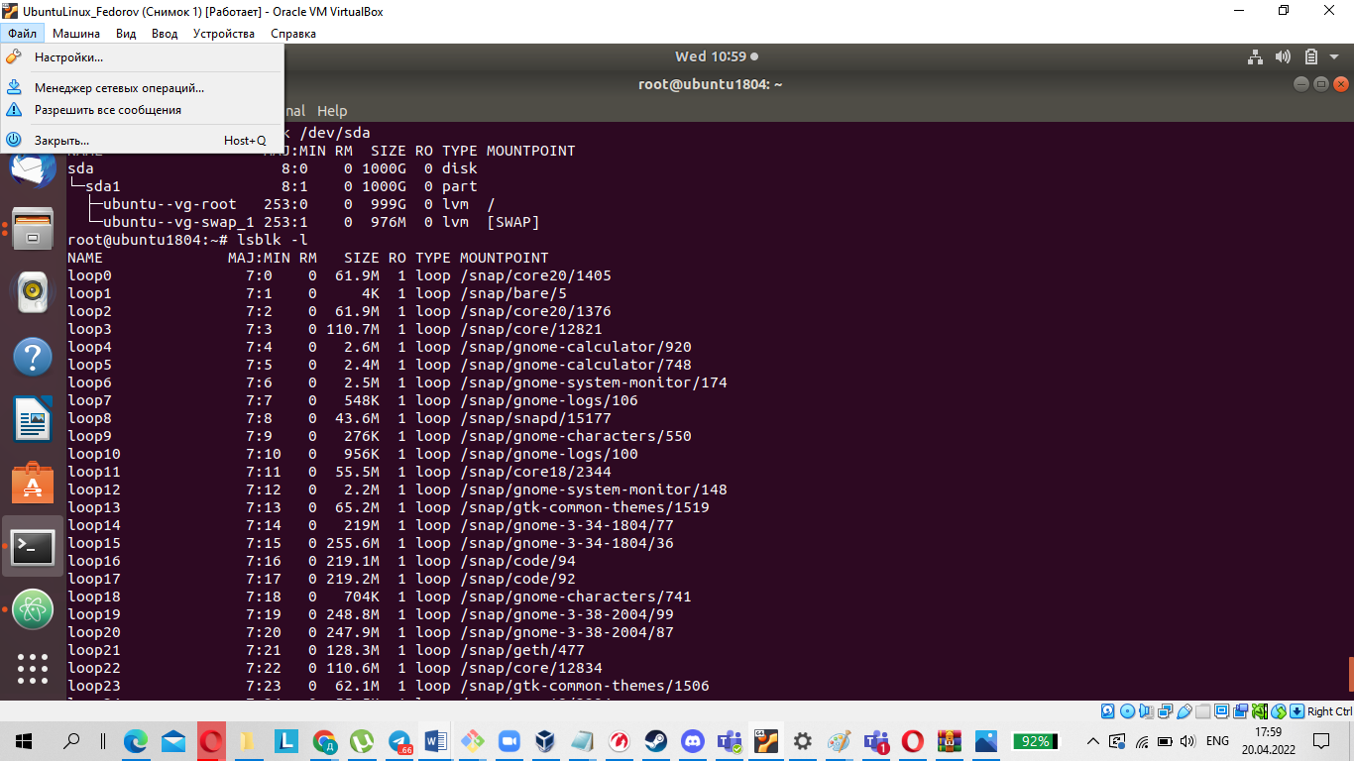

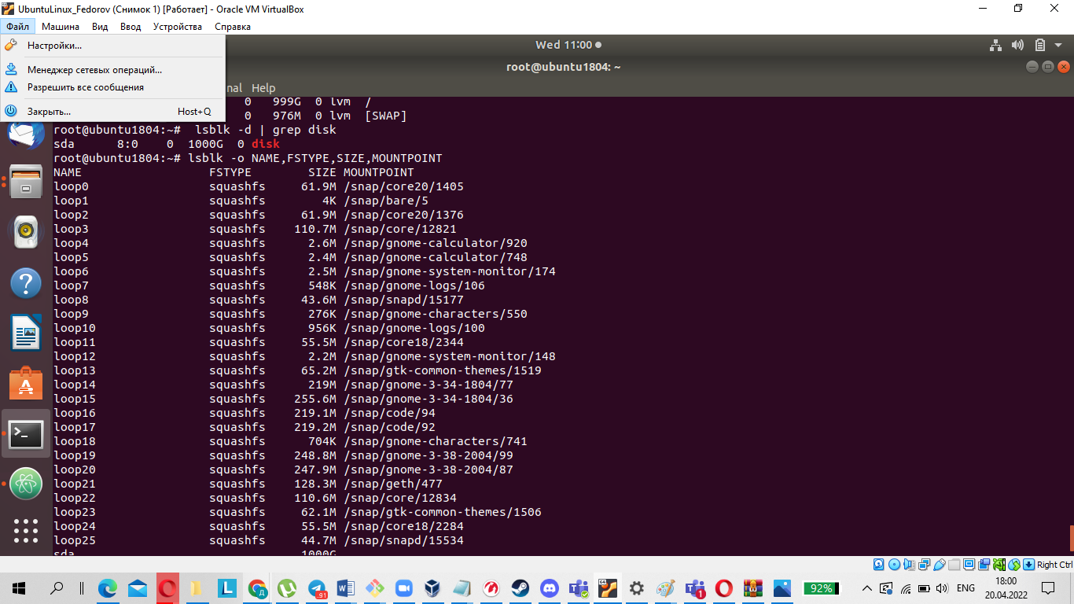

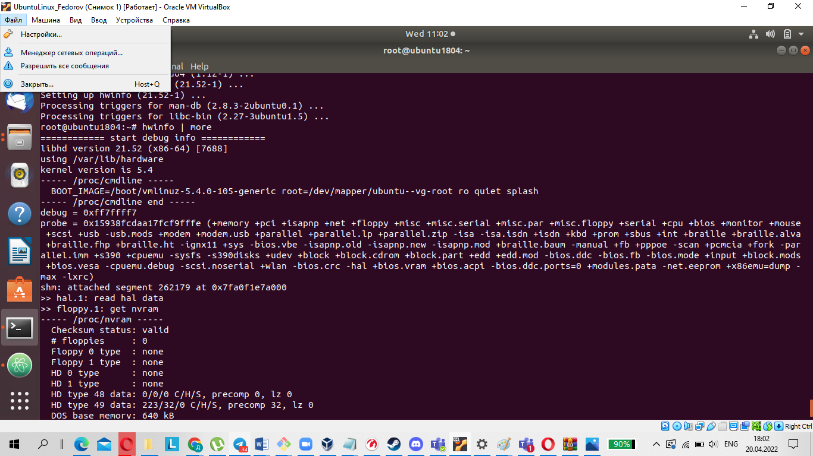

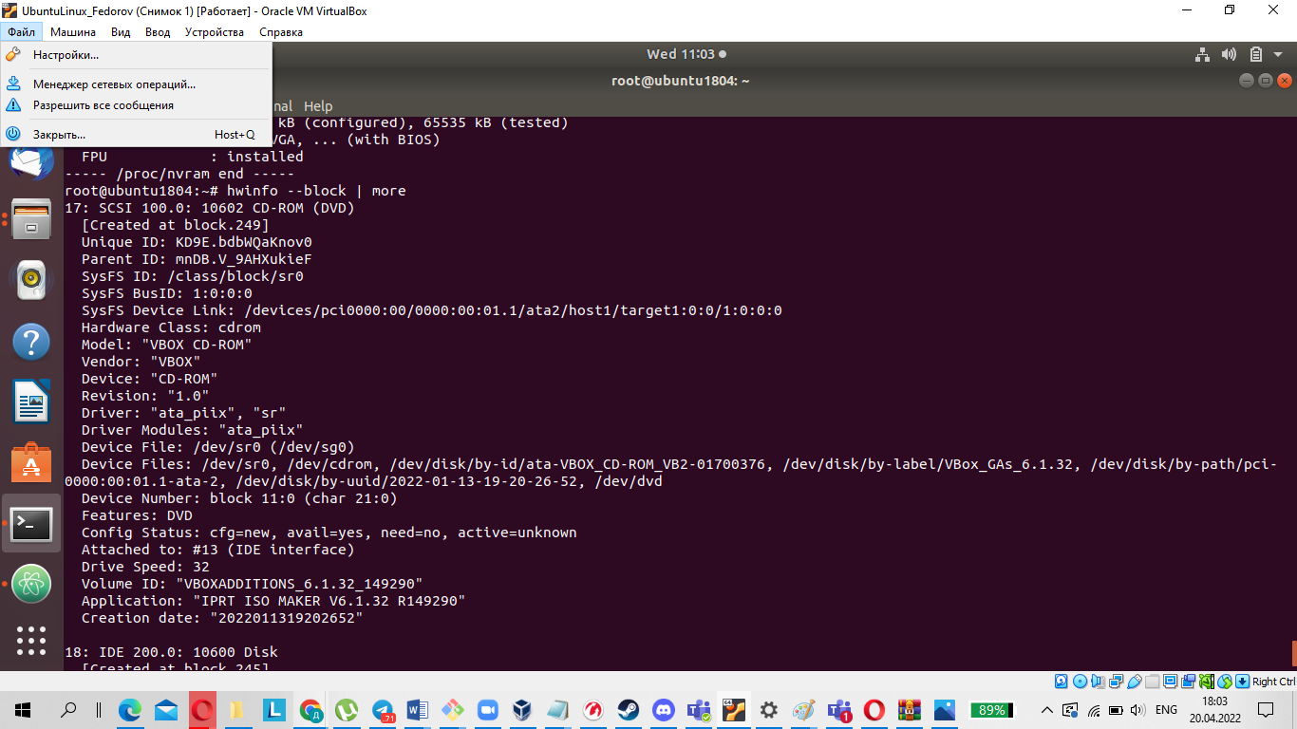

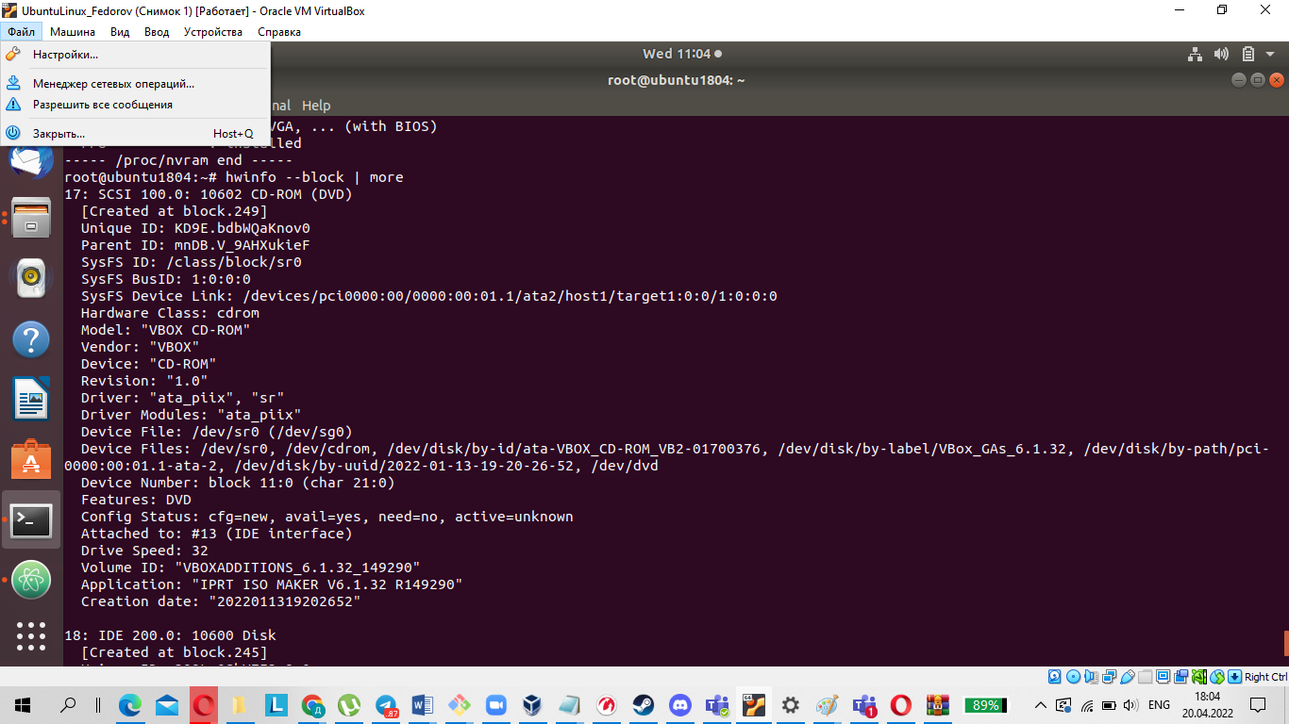

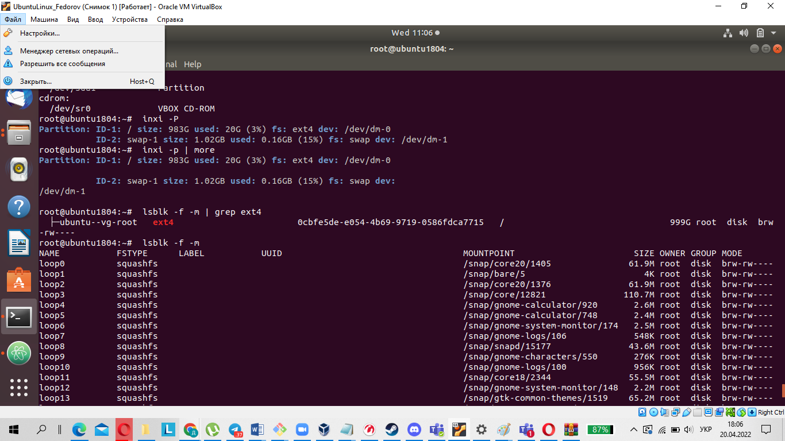

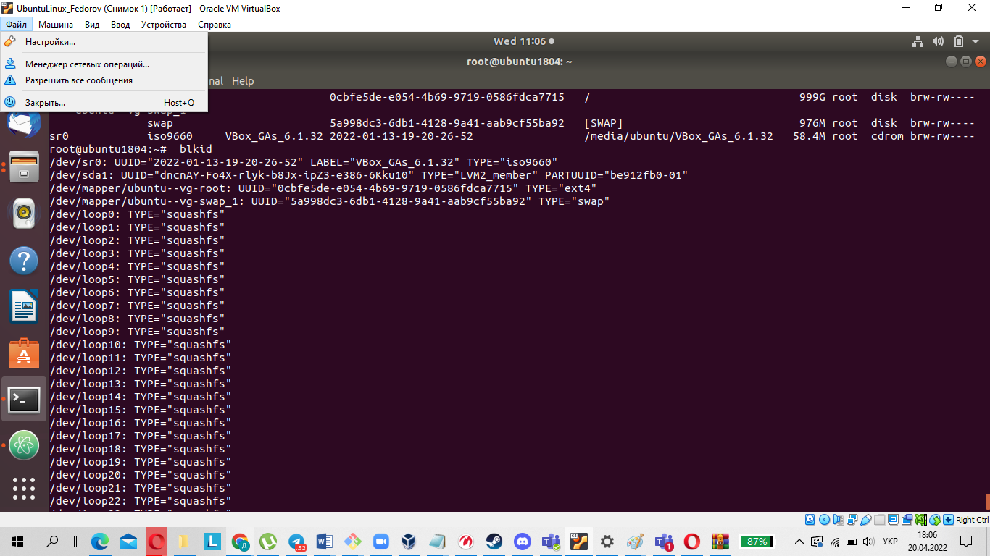

9. Count the number of lines containing a given sequence of characters in a given

file.

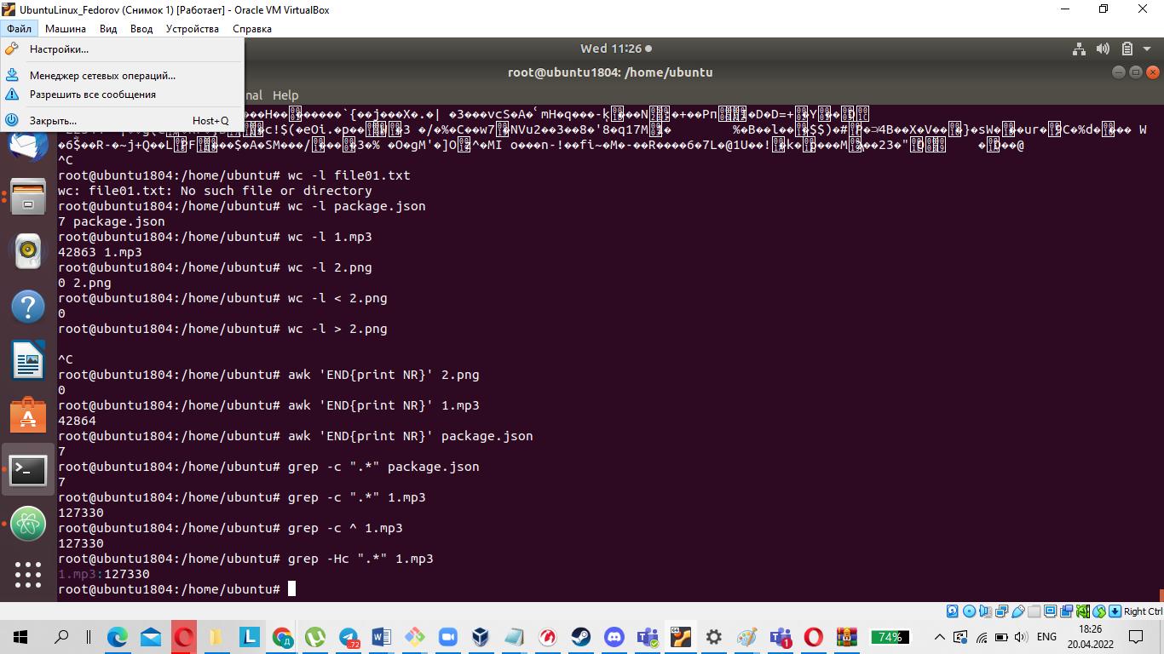

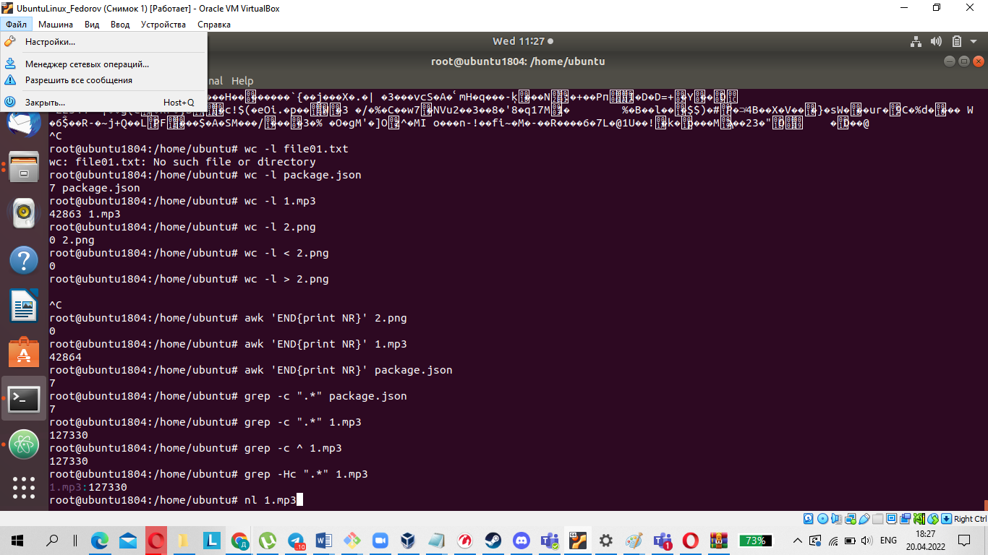

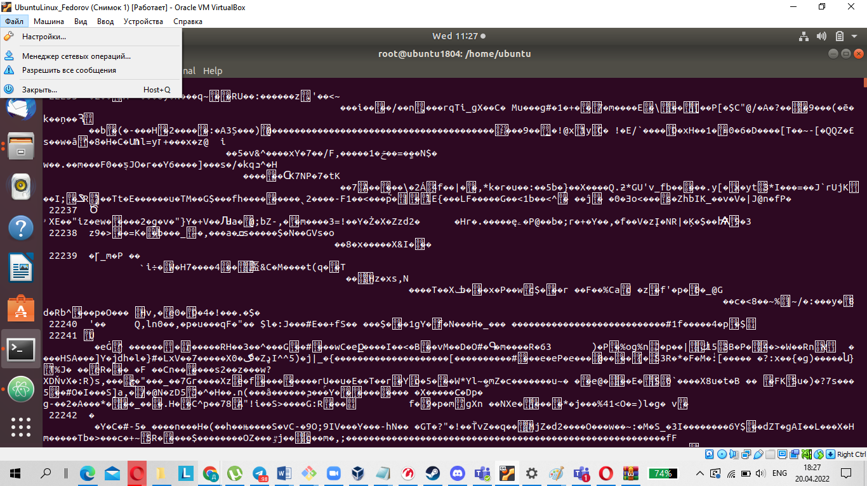

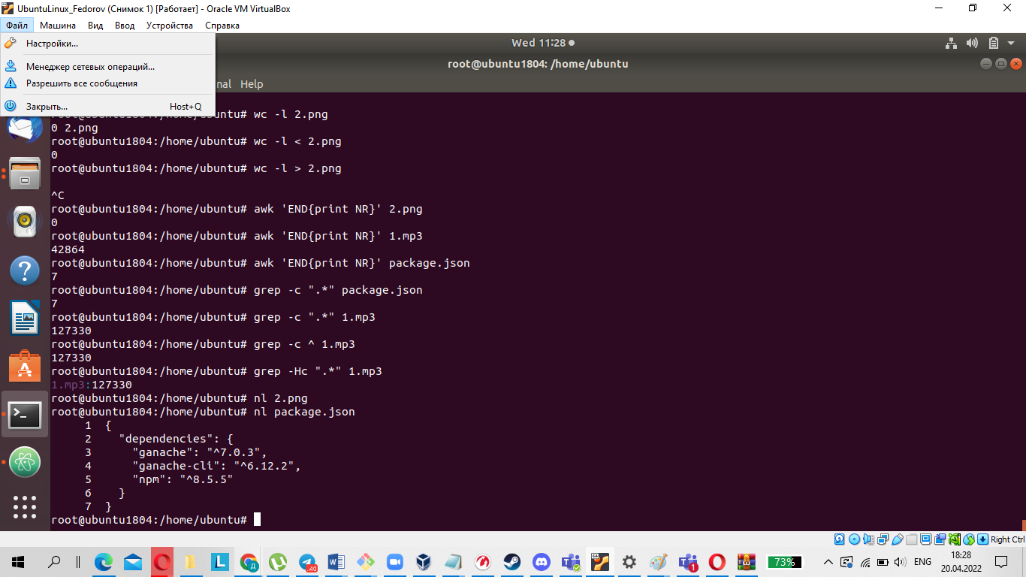

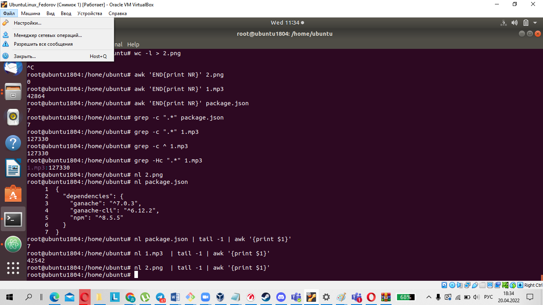

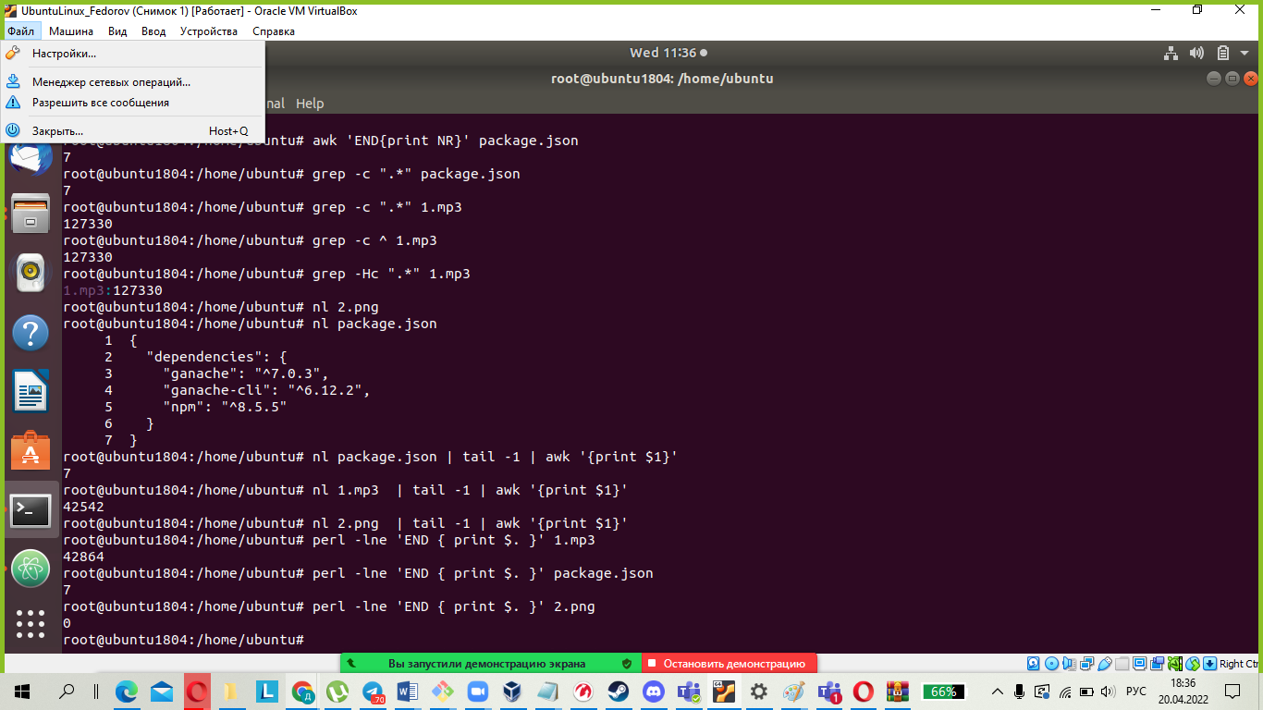

10.Using the find command, find all files in the /etc directory containing the

host character sequence.

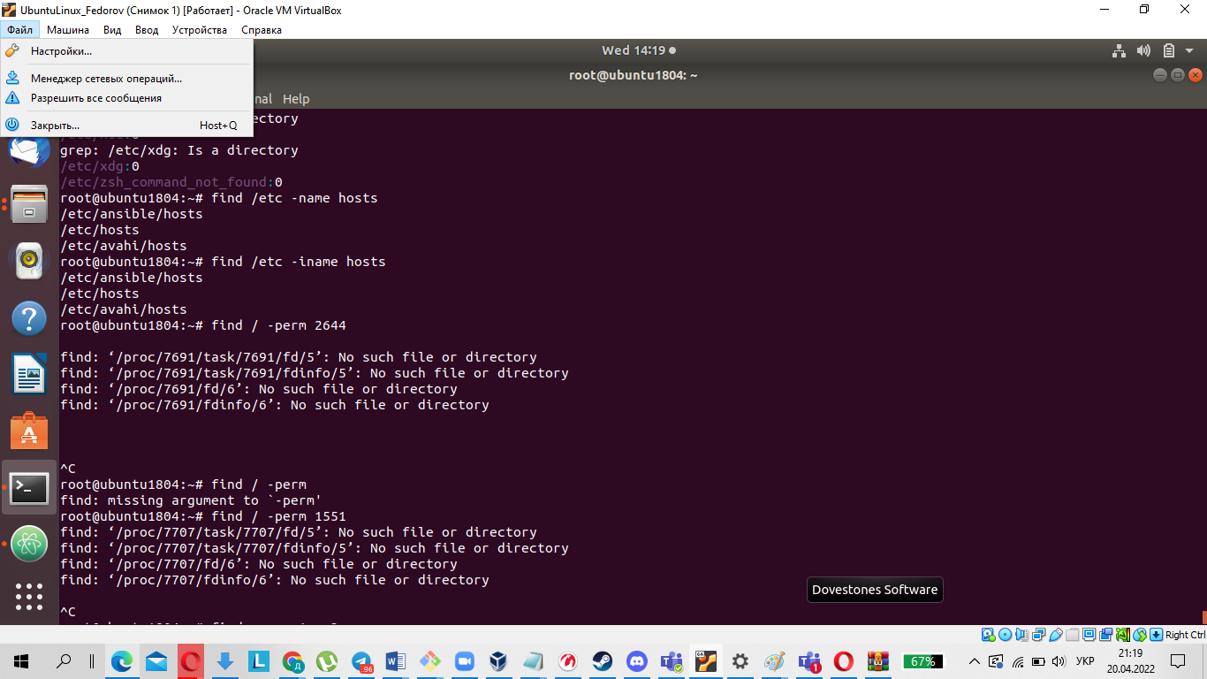

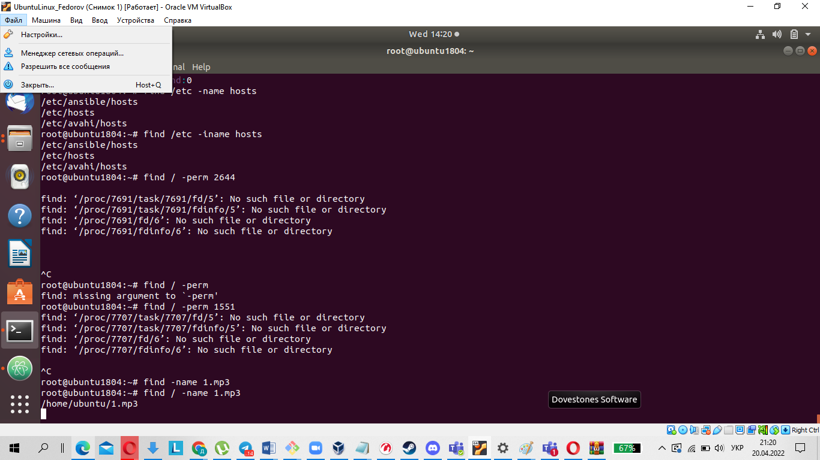

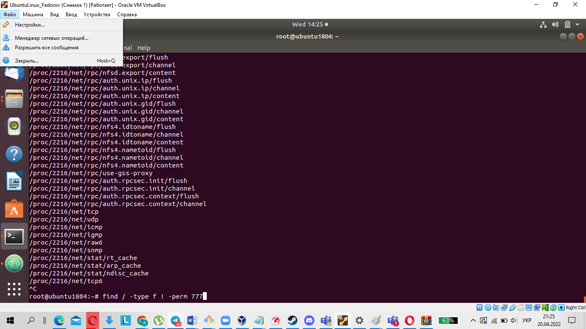

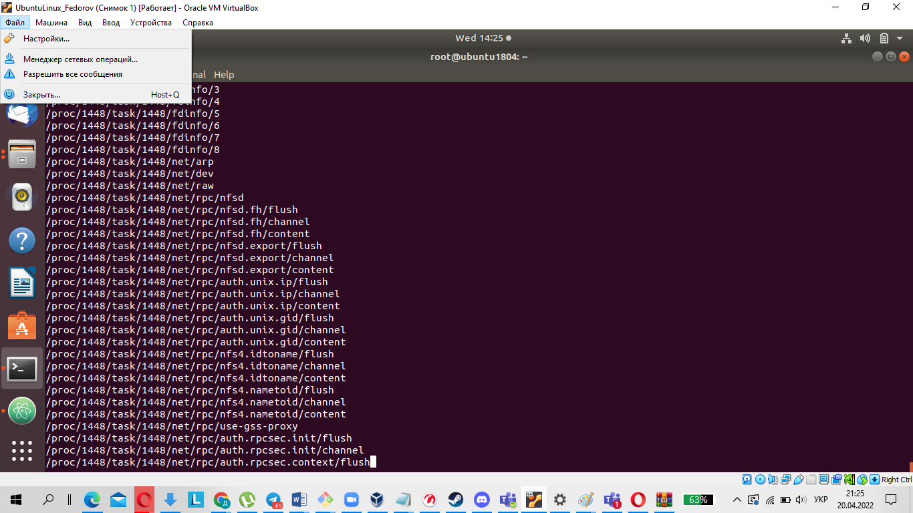

11.List all objects in /etc that contain the ss character sequence. How can I duplicate a similar command using a bunch of grep?

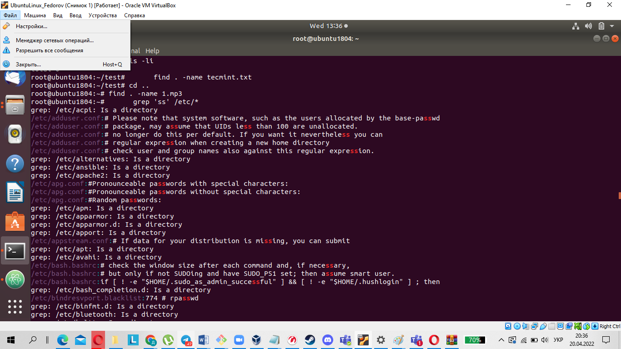

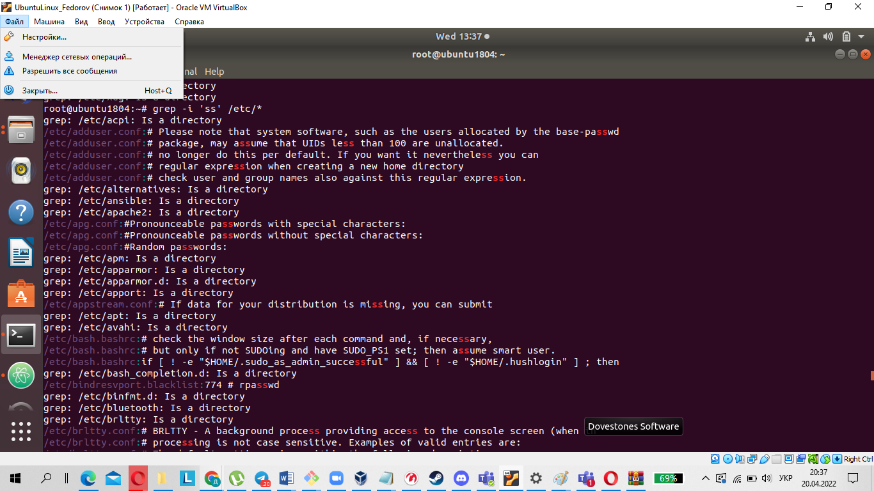

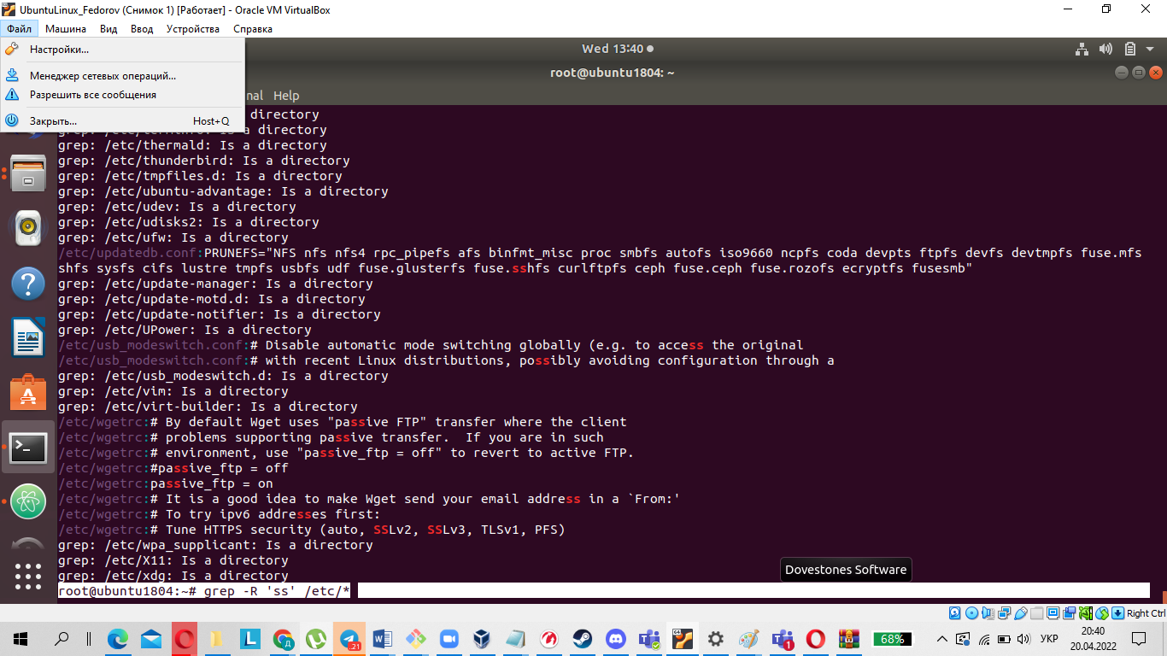

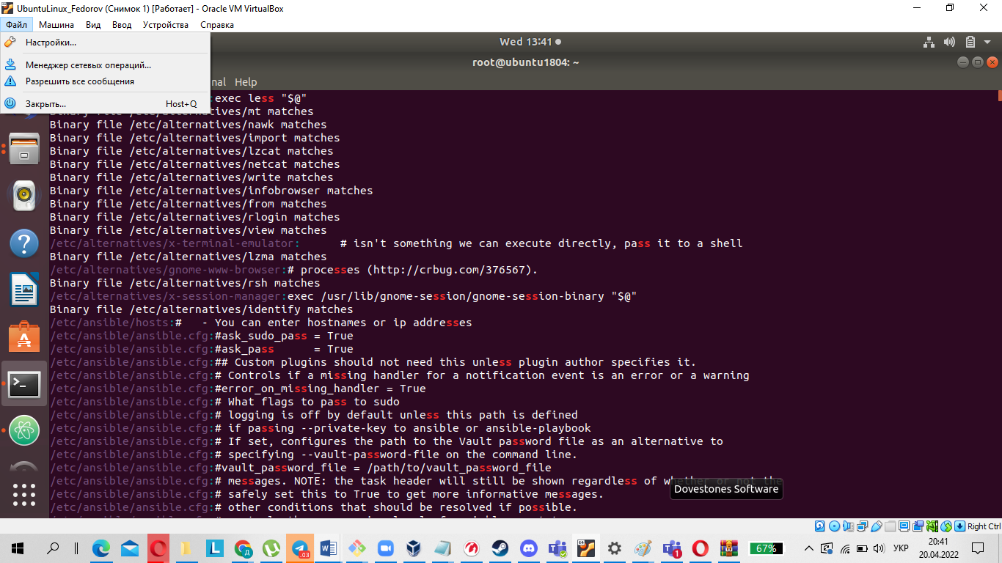

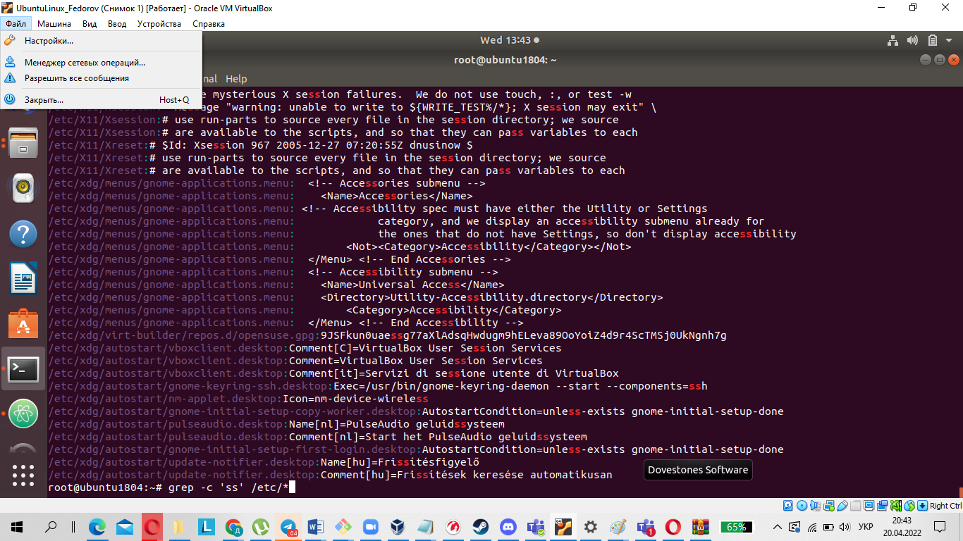

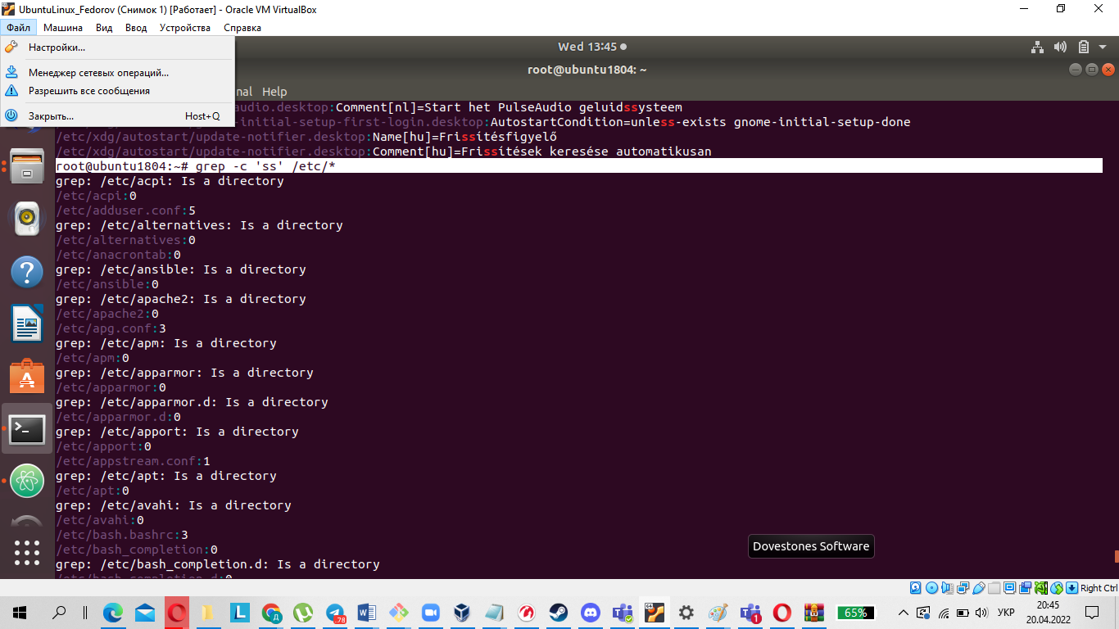

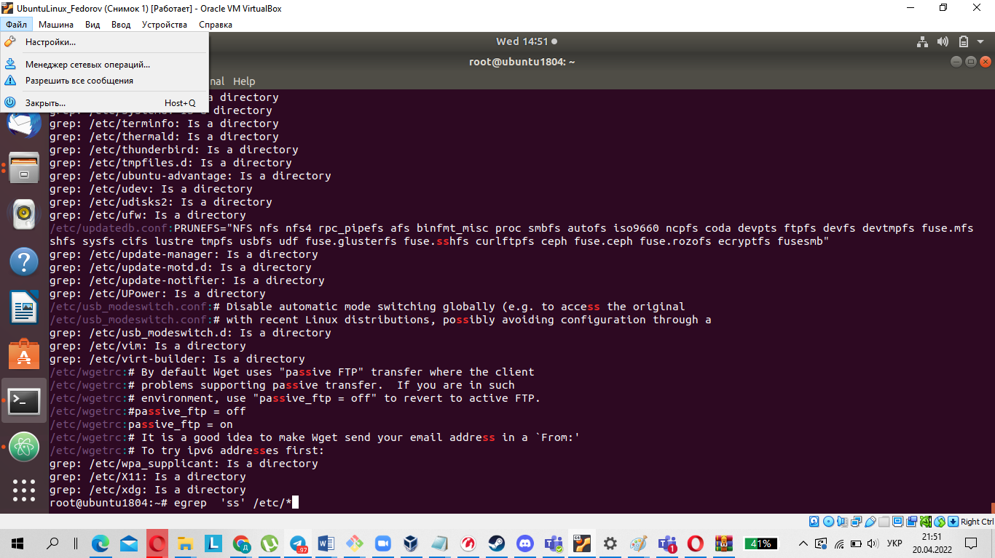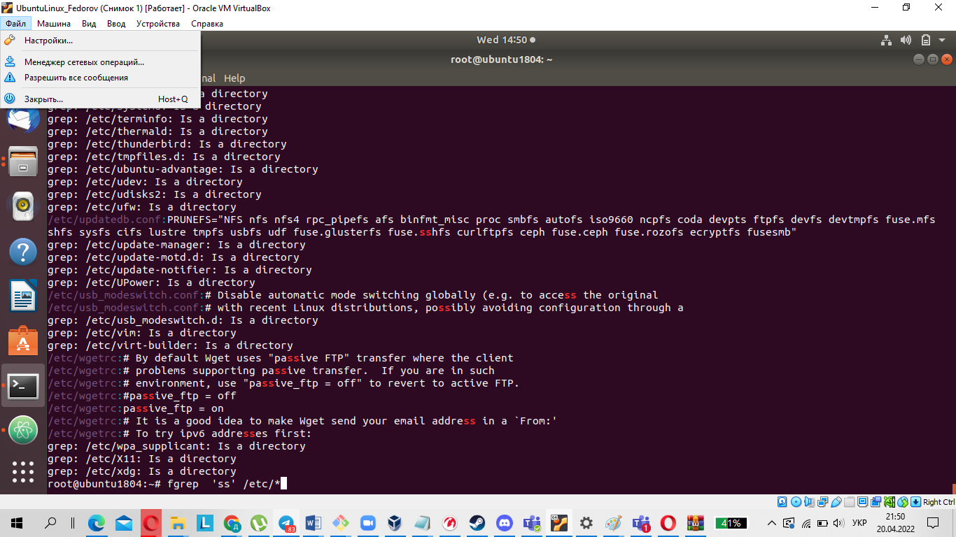

Grep is a Linux command line utility that gives users the ability to search for a string. It can even be used to search for specific words in a file. It is also possible to pass the output of any command to grep, which makes it very easy to work while searching and trawling.

Egrep is the same as grep E . An extended regular expression is passed to this command as a pattern.

Example:

1 $ grep -C 0 '(f|g)ile' example.txt

2 $ grep -C 0 '\(f\|g\)ile' example.txt

Fgrep is a grep F command that treats the passed pattern as a list of fixed string data. This command is useful when the pattern uses characters reserved for regular expressions, which normally grep would have to escape.

Example:

1 $ fgrep -C 0 '(f|g)ile' example.txt

2 $ fgrep -C 0 '\(f\|g\)ile' example.txt

12.Organize a screen-by-screen print of the contents of the /etc directory. Hint:

You must use stream redirection operations.

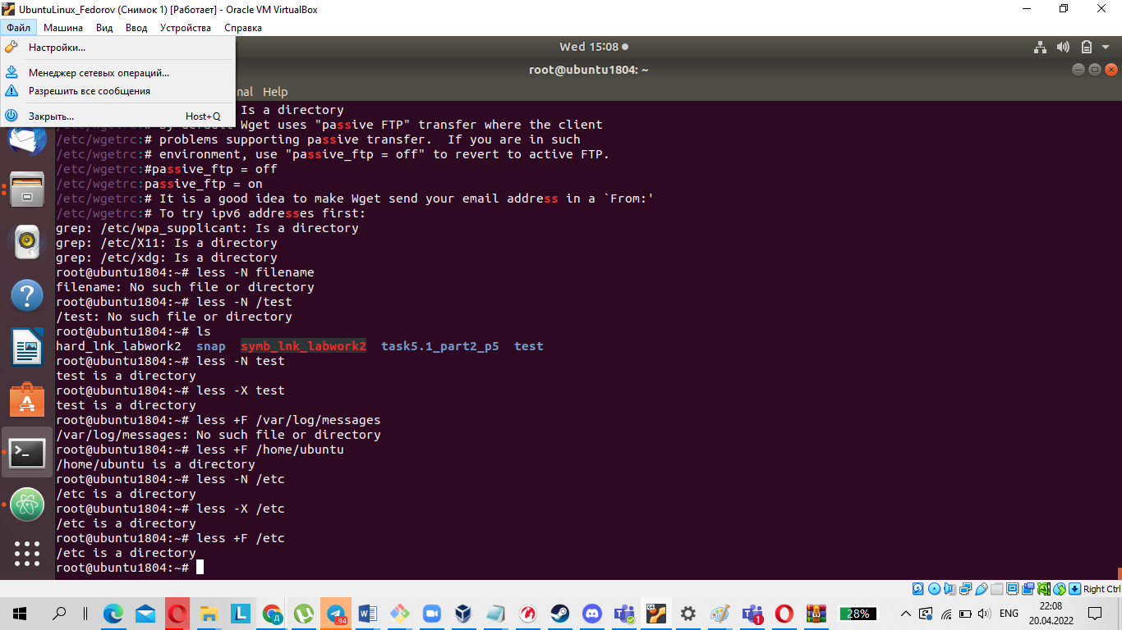

13.What are the types of devices and how to determine the type of device? Give

examples.

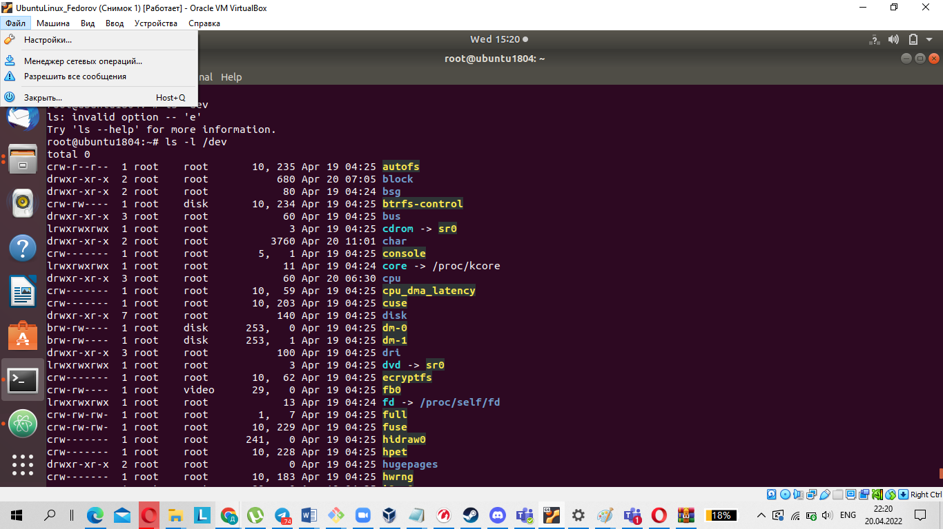

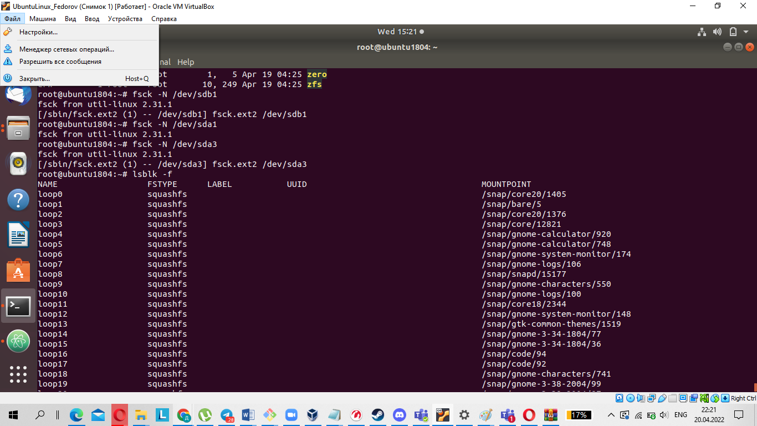

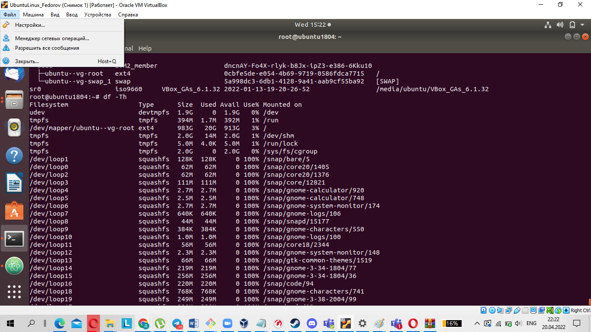

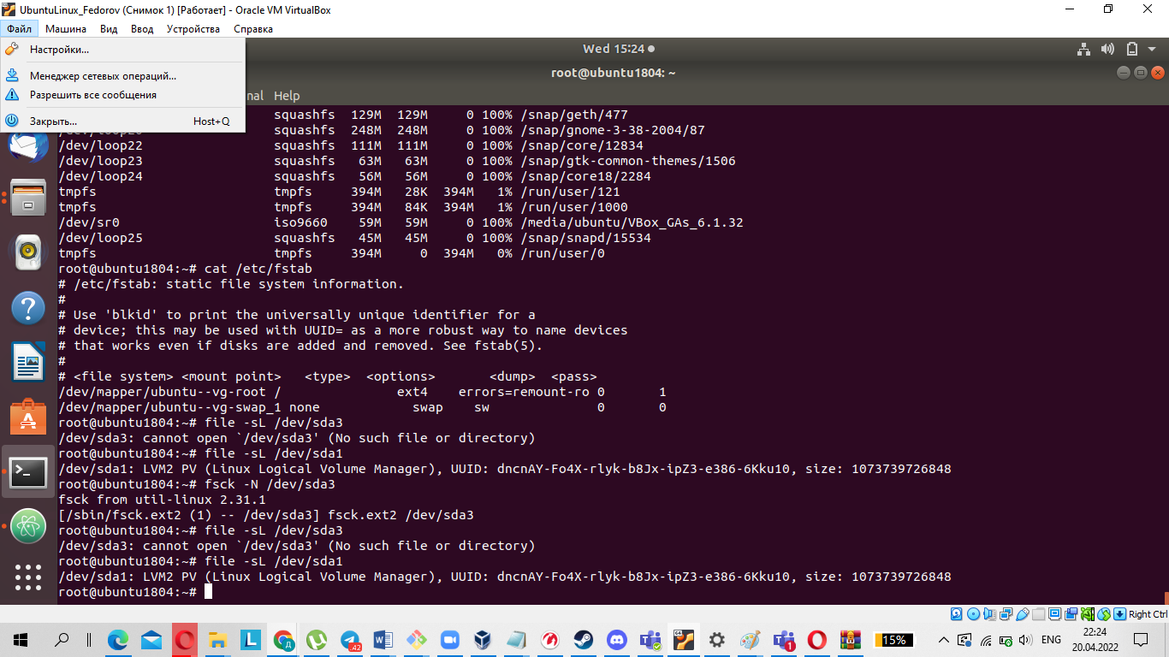

**Character Device**

Character special files or character devices provide unbuffered, direct access to the hardware device. They do not necessarily allow programs to read or write single characters at a time; that is up to the device in question. The character device for a hard disk, for example, will normally require that all reads and writes be aligned to block boundaries and most certainly will not allow reading a single byte.

**Block Device**

Block special files or block devices provide buffered access to hardware devices, and provide some abstraction from their specifics.Unlike character devices, block devices will always allow the programmer to read or write a block of any size (including single characters/bytes) and any alignment. The downside is that because block devices are buffered, the programmer does not know how long it will take before written data is passed from the kernel's buffers to the actual device, or indeed in what order two separate writes will arrive at the physical device. Additionally, if the same hardware exposes both character and block devices, there is a risk of data corruption due to clients using the character device being unaware of changes made in the buffers of the block device.

**Pipe Device**

Named pipes allow two or more processes to communicate with each other, these are similar to character devices, but instead of having output sent to a device, it's sent to another process.

**Socket Device**

Socket devices facilitate communication between processes, similar to pipe devices but they can communicate with many processes at once.

14.How to determine the type of file in the system, what types of files are there?

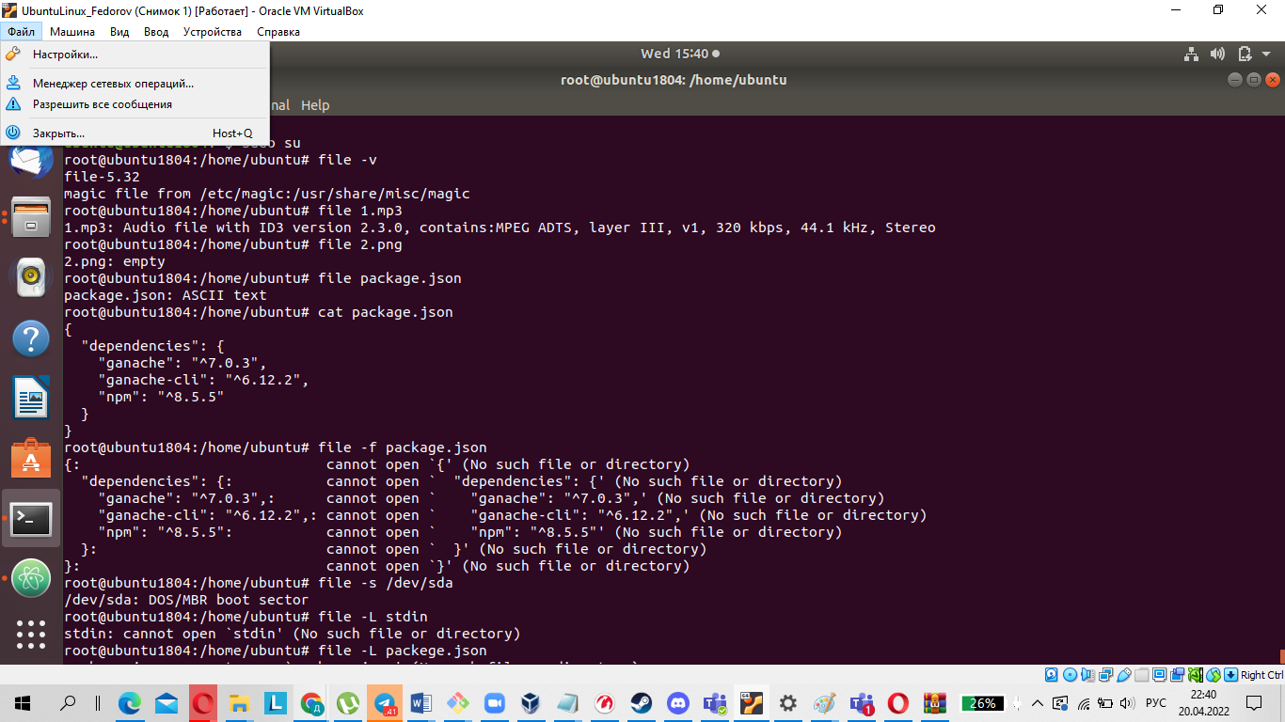

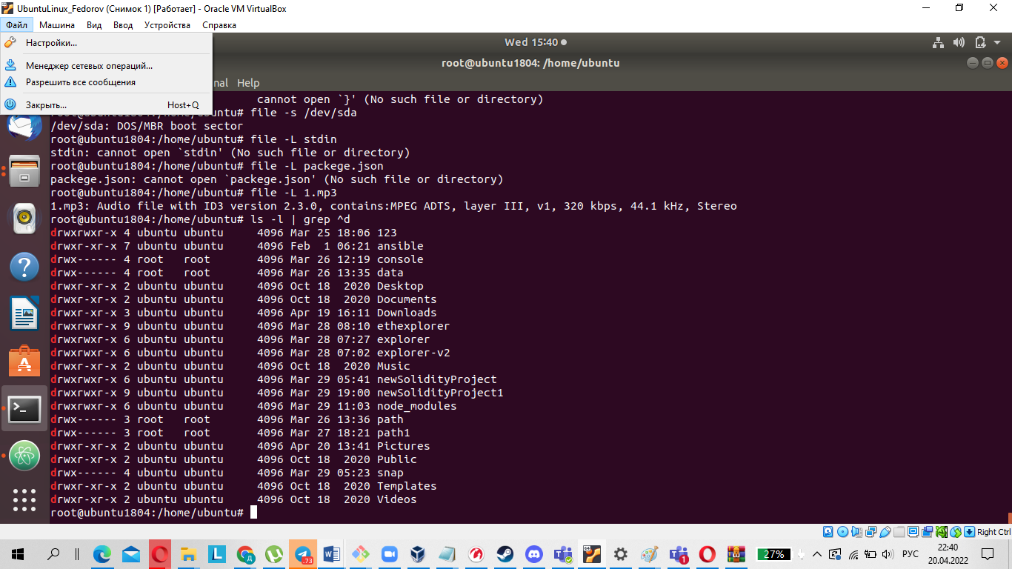

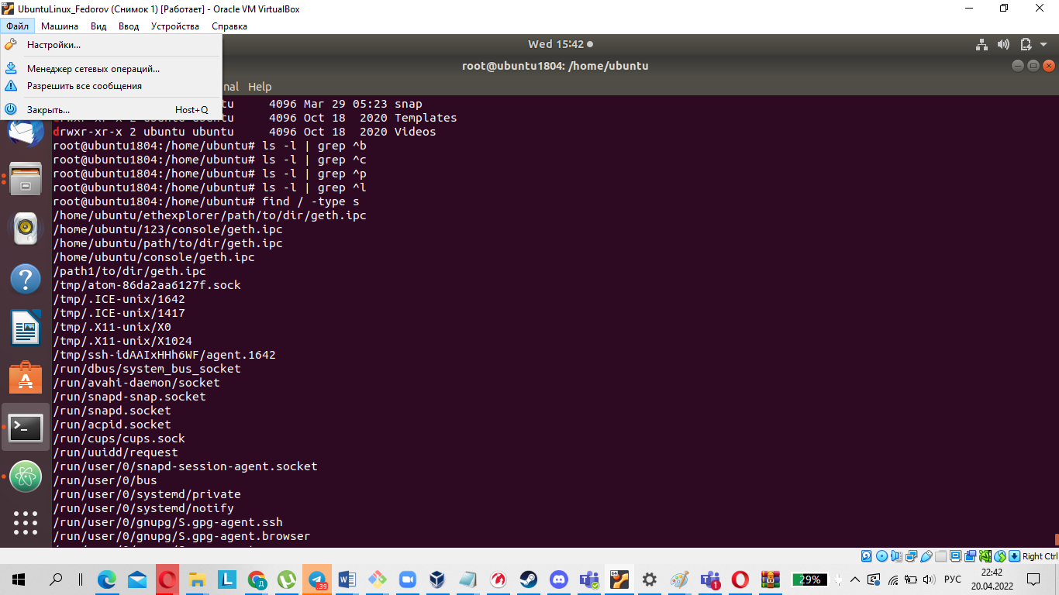

File type:

Ordinary or regular files

Directory files

Block or character special files

Link files

Socket files

Named pipe files

15.List the first 5 directory files that were recently accessed in the /etc

directory.

